

Graduation Project

**Future University in Egypt**

**Faculty of Computers and Information Technology**

**Department of Computer Science**

|  |
| --- |
|  |

|  |  |  |
| --- | --- | --- |
| *Prepared by* | | |
| ID | | **Name** |
|  | **20184434** | **Mahmoud Khaled Kamal** |
|  | **20181995** | **Sama Mohamed Nasr** |
|  | **20181435** | **Nada Wael Mohamed** |
|  | **20183563** | **Gehad Hussien Saleh** |
|  | **20183545** | **Mazen Nabil** |
|  | **20184997** | **Muhamad Abdelgelil** |

**IoT and AI Based Indoor Navigation System for Visually Impaired People**

**Supervised by**

**Prof. Mohamed Abdel Azize Abdel Razek**

**TA. Hadeer El-ziat**

**Acknowledgment**

It has been a wonderful opportunity to learn how to analyze and design real projects while also gaining a lot more experience working on them in real-time. We would like to express our gratitude to everyone who makes it possible for students like us. A special thank you to the graduation project unit for all the work they put into getting us all the relevant material and opening the way for the students to apply all the knowledge they had learned in actual project design and analysis. Furthermore, we thank all the professors and visiting industry for the interesting lectures they presented which had great benefit for all of us. We want to express our heartfelt appreciation to our graduation project supervisor **Prof. Mohamed Abdel Azize Abdel Razek** for his patience and guidance throughout the semester. Moreover, it is our pleasure to thank the members of the testing committee for their encouragement and generous discussions. Finally, we would also like to thank our university FUE, assembled by **Prof. Ebada Sarhan**, for giving us the chance to graduate, and for all our parents for their encouragement and support.

**Abstract**

Visually impaired humans are usually unrealizable of the danger that they face in their daily life. They may face several obstacles once performing their daily activities. This project introduces an aid impaired people system which helps visually impaired people to recognize the environment surrounding them. It helps them to detect and recognize the tools around them, which they see through a mobile camera. It is connected to a system that recognizes the environment and provides the output as a voice message. The system imitates the human eye. A mobile camera captures an image as an input for the model that employs a neural network for recognition of pre-trained objects with a considerable accuracy on the Microsoft Common Objects (MS-COCO) dataset. The system will return the name of the object as an audio. The process of analysis using long complex algorithms known as the convolutional neural network algorithms. The algorithm analyzes the images into parts to compare them with the most important features of the objects in the pictures related to the dataset. The description of the captured image generated by LSTM and result will be converted to a voice message to tell the visually impaired people about the environment in front of them. Also, we developed a hardware device which calculates the distance between visually impaired person and the objects to alert him.

**Table of Figures**

Figure 1. ImageNet Dataset 27

Figure 2. COCO Dataset 28

Figure 3. Transfer Learning 30

Figure 4. CNN Flowchart 31

Figure 5. VGG16 32

Figure 6. Inception V3 33

Figure 7. VGG19 34

Figure 8. ResNet50 35

Figure 9. LSTM Model 37

Figure 10. Greedy Search 40

Figure 11 Beam Search 41

Figure 12. Ultrasonic 42

Figure 13. Buzzer 42

Figure 14. Arduino Nano 43

Figure 15. HC-05 Bluetooth Module 43

Figure 16 System Architecture 45

Figure 17 Application Life Cycle 46

Figure 18. MVVM 48

Figure 19 Use Case Diagram 49

Figure 20 User interface 51

Figure 21 User interface 52

Figure 22 Android Permission Code 52

Figure 23 Android Permission Code 52

Figure 24 Android Permission Code 53

Figure 25 Android Permission Request 53

Figure 26 Camera Interface 53

Figure 27 Countdown Timer 54

Figure 28 Phone Gallery 54

Figure 29 CNN-LSTM Architecture 56

Figure 30 CNN-LSTM Model 57

Figure 31 Image Captioning Result 57

Figure 32 Circuit Design 60

Figure 33 Circuit Implementation on glasses 61

Figure 34 Circuit Implementation on glasses 61

Figure 35 Plot Training Accuracy for Proposed Model 65

Figure 36 Plot Training Loss for Proposed Model 65

Figure 37 VGG16 Prediction Example 66

Figure 38 VGG16 Prediction Example 66

Figure 39 Plot Training Loss for Proposed Model 68

Figure 40 Plot Training Accuracy for Proposed Model 68

Figure 41 VGG19 Prediction Example 69

Figure 42 VGG19 Prediction Example 69

Figure 43 Plot Training Accuracy for Proposed Model 71

Figure 44 Plot Training Loss for Proposed Model 71

Figure 45 Inception V3 Prediction Example 72

Figure 46 Inception V3 Prediction Example 72

Figure 47 Inception V3 Prediction Example 73

Figure 48 Plot Training Accuracy for Proposed Model 76

Figure 49 Plot Training Loss for Proposed Model 76

Figure 50 Plot Training Accuracy for Proposed Model 78

Figure 51 Plot Training Loss for Proposed Model 78

Figure 52 ResNet50 Prediction Example 79

Figure 53 ResNet50 Prediction Example 79

Figure 54 ResNet50 Prediction Example 80

Figure 55 ResNet50 Prediction Example 80

Figure 56 ResNet50 Prediction Example 81

Figure 57 ResNet50 Prediction Example 81

**List of Tables**

Table 1 ResNet50 Results 40 epoch 75

Table 2 ResNet50 Results 2500 Epoch 77

Table 3 VGG16 Results 64

Table 4 VGG19 Results 67

Table 5 Inception V3 Results 70

Table 6 Keras Example Results 74

Table of Contents

1.1 Introduction 9

1.2 Problem Statement 11

1.3 Approach 12

1.4 Project Goals 12

1.5 Project Objectives 12

1.6 Project Organization 13

2.1 Related Works 15

3.1 Introduction 28

3.2 Dataset 29

3.1.1 Flicker Dataset 29

3.1.2 ImageNet dataset 29

3.1.3 COCO Dataset 30

3.1.4 Why using COCO dataset? 33

3.3 Software 34

3.2.1 Transfer Learning 34

3.2.2 Convolutional Neural Networks 35

3.2.3 Different Types of CNN Architectures 36

3.2.3.1 VGG16 36

3.2.3.2 Inception V3 Model 37

3.2.3.3 VGG-19 38

3.2.3.4 ResNet50 39

3.2.4 Recurrent Neural Networks 40

3.2.5 LSTM 40

3.2.5.1 LSTM Applications 40

3.2.6 TensorFlow 42

3.2.7 Keras 42

3.2.8 Differences between Accuracy and loss in image captioning problem? 42

3.4 Decoding Types 43

3.3.1 Greedy search 44

3.3.2 Beam search 44

3.3.3 Why greedy search is better than beam search in this project? 46

3.5 Hardware 47

3.4.1 Ultrasonic sensor 47

3.4.2 Buzzer 47

3.4.3 Aurdino Nano 48

3.4.4 HC-05 Bluetooth Module 48

4.1. System Architecture 50

4.2. Application Life cycle 51

4.3. System Models 52

4.3.1. Software architecture pattern 52

4.3.1.1 What is MVP? 52

4.3.1.2 What is MVC? 52

4.3.1.3 Why use MVVM instead of using MVC and MVP? 53

4.4. Use Case Diagram 54

5.1. User Interface 56

5.2. Software Implementation 60

5.2.1. Image Captioning 60

5.2.2. The CNN-LSTM Model 61

5.2.2.1 Encoder 63

5.2.2.2 Decoder 63

5.2.2.3 Training 63

5.2.2.4 Testing 63

5.2.2.5 Image pre-processing 63

5.2.2.6 Read images 64

5.2.2.7 Text Pre-processing 64

5.3. Hardware Implementation 65

5.3.1 Circuit Design 65

5.3.2 Circuit Implementation 66

5.4. System Deployment 67

6.1. VGG16 Results 69

6.2. VGG19 Results 72

6.3. Inception V3 75

6.4. Keras 79

6.5. ResNet50 Results 80

7.1. Future Work 88

7.2. Conclusion 89

References 93

A Convolutional Neural Network based Live Object

Recognition System as Blind Aid

Kedar Potdar

Student, New York University

New York City,

NY USA 11209

kedar1916@gmail.com

Chinmay D. Pai

Student, Computer Engineering

WIEECT, Worli

Mumbai, INDIA, 400 018

chinmaydpai@gmail.com

Sukrut Akolkar

Student, Computer Engineering

WIEECT, Worli

Mumbai, INDIA, 400 018

sukrutakolkar@gmail.com

Abstract—This paper introduces a live object recognition

system that serves as a blind aid. Visually impaired people heavily

rely on their other senses such as touch and auditory signals for

understanding the environment around them. The act of knowing

what object is in front of the blind person without touching it

(by hands or using some other tool) is very difﬁcult. In some

cases, the physical contact between the person and object can be

dangerous, and even lethal.

This project employs a Convolutional Neural Network for

recognition of pre-trained objects on the ImageNet dataset. A

camera, aligned with the systems pre-determined orientation,

serves as input to a computer system, which has the object

recognition Neural Network deployed to carry out real-time

object detection. Output from the network can then be parsed to

present to the visually impaired person either in form of audio

or Braille text

Chapter One

Introduction

# Introduction

The vision impairment is one of the most common disabilities among people across the world of all ages. The society comes across millions of blind people in everyday life. The white cane is the most common used blind aid tool serving mobility purposes to the visually impaired people. These people with vision impairments lead difficult lives that cannot be managed without smart supportive techniques. With advancements in technology, new tools are being built which aid the visually impaired human not only with mobility, but also with better understanding of the surrounding tools, this system utilizes object recognition with deep learning to help the visually impaired person. The proposed technique acquires the deep-learning concept to finalize and solve the ongoing problems faced by the visually impaired people. The system helps visually impaired people to recognize the environment they are in as well as the various objects in their everyday life whatever the impact on the item's features or if their view is obstructed, as this is one of the very first skills, we learn from the moment we are born. On the other hand, computers need work, powerful computation, and complicated algorithms to try to correctly find patterns and places where a probable object might exist.

Akolkar, et al. (2018) presents a Real-time object recognition system that helps visually impaired people. This project depends on Convolutional Neural Network for the recognition of pre-trained objects on the ImageNet dataset. By using a camera aligned with the system, the captured image is transferred to the computer system for processing and the input to the computer comes from the server, which has the model to carry out live object detection. The output from the server is either Braille text or Audio. The system works by pressing a button to capture the data.

[Alisetti](https://www.researchgate.net/profile/Sai-Nikhil-Alisetti), et al. (2019)offers the user a personalized assistant, where they can communicate naturally via their voice to replicate the support of a real human. Their project works by using its object detection module with a high-reliability training accuracy to detect the boundaries of objects in motion per frame and once the bounding box crosses the threshold accuracy. Their project is dependent on two core architectures working together in harmony. These architectures are resilient, dependable, and compassionate, with natural interactive voice help given by a context tree-based answering algorithm. The object detection CNN is pre-trained on the dataset. Since their model is a reinforcement learning model, it will be more optimized the more it is used in a certain area or with certain types of objects.

Alhichr, et al. (2020) presents a scene and inform the visually impaired user about them using voice communications. Their module is designed to assist them in navigating indoor environments, detecting, and reading text information, detecting, and recognizing faces, and detecting and listing objects present in the scene. A camera is placed on the visually impaired person’s chest connected to a portable device. The results are based on the ordered weighted averaging (OWA) technique and the merging of a two-deep CNN models, Squeeze Net and VGG16. We must predict a confidence measure in the output of the two CNN base models in order to use the output of owa approach. At first, they trained their model. Then, computed the residual errors for all training images. After, the training phase they predicted the objects by CNN models. Then, the model is used to estimate the residual errors of both main CNN models to fuse the outputs based on the induced OWA approach.

Mahendran, et al. (2021) presents a voice-activated backpack powered by AI that can assist those who are blind in navigating and understanding their surroundings. The backpack works with a low-power interactive device to identify everyday barriers including crosswalks, hanging objects, traffic signs, and moving objects.

Their system is placed inside a tiny backpack that also has a host computer, possibly a laptop. A vest jacket is used to cover a camera, and a pack is used to keep a pocket-sized battery fanny pack that can last for about eight hours. You can attach a Luxonis Oak D Spatial AI camera to your vest or a fanny pack and connect it to your backpack's computer. The OAK-D, which is mounted to the inside of the vest, has viewports through three holes in the vest. The user can interact with system via voice commands and questions through a Bluetooth earpiece, and the system responds with vocal information. The system transfers information about common obstructions, such as tree branches, signs, and pedestrians, as the user walks through their environment. Additionally, it sends warnings for approaching curbs, crosswalks, and staircases.

# Problem Statement

Suppose that someone lost his sight in a car accident, so he became visually impaired. This affected him totally including emotional and social relationships. He faces many obstacles while performing his daily activities. He moved to a new place. The biggest challenge for him, was to navigate around the rooms. He was home alone so he couldn’t recognize the rooms or walk freely around the house as he was afraid to stumble.

It is difficult for visually impaired people to navigate or identify objects due to, the limited accessibility to activities and information. Visually impaired persons must remember the position of every obstacle or object in their home. To avoid accidents, don't move furniture like tables, chairs, and beds in the kitchen or bedroom without first provide warning. If a visually impaired human live with other people, each member of the house must take care about keeping walkways clear and everything in their proper place.

Also visually impaired people can’t differentiate between objects of the dimensions for example a phone and a small notebook. there are some ways for dealing with such problem for example to put some stickers on the individual objects for easy identification of a particular object. This method is limited to some objects. Consequently, we need to develop a more efficient way to solve such problems.

# Approach

We developed a system called Smart Eye. This system can help a visual impaired person to navigate home. The system is built based on CNN (ResNet50) and LSTM. CNN model extract features. Then, detects and recognizes all the objects/places in the image. LSTM generates a description of it. The description then is converted to speech. Finally, the user receives the output as a voice message. The interface at the frontend is built using an android application using JAVA native language to help the visually impaired. The application captures images automatically using the mobile camera and then, the captured image is converted to Base64 then it will be transferred to a deep learning model using the API.

# Project Goals

The goal of our project is to develop a system that helps visually impaired people in their navigation. This application facilitates the quality of user’s life.

# Project Objectives

The system is implemented to detect environment based on important features of the objects in the images related to the dataset.

The images of the environment are captured by the user automatically, then object detection and image processing are performed to detect environment to deliver voice to user about the objects in front of them.

According to the results, visually impaired persons will be more aware of their surroundings, and the suggested system would help them learn more about the various challenges they may face them.

# Project Organization

This report is organized as follows: chapter one presents the introduction, problem statement, suggested approach, project goals and project objectives. Chapter two presents: related works. Chapter three presents: transfer learning, CNN, CNN architectures, RNN, LSTM and hardware (ultrasonic, buzzer, Arduino nano and HC-05 Bluetooth module. Chapter four presents: application life cycle, system architecture, software architecture plan and use case diagram. Chapter five presents: user interface, software implementation, hardware implementation and system deployment. Chapter six presents: ResNet50 results, VGG16 results, VGG19 results, Inception V3 results and Keras results. Chapter seven presents: future work and conclusion.

Chapter Two

Related Work

# Related Works

Bazi, et al (2016) presents a Multiple Object Scene Description for the Visually Impaired Using Pre-Trained Convolutional Neural Networks. This paper introduces a new method for multiple object scene description as part of a system to guide the visually impaired in an indoor environment. Here we are interested in a coarse scene description, where only the presence of certain objects is indicated regardless of its position in the scene. The proposed method is based on the extraction of powerful features using pre-trained convolutional neural networks (CNN), then training a Neural Network regression to predict the content of any unknown scene based on its CNN feature. We have found the CNN feature to be highly descriptive, even though it is trained on auxiliary data from a completely different domain. The proposed methodology was assessed on four datasets representing different indoor environments. It achieves better results in terms of both accuracy and processing time when compared to state-of-the art.

Kumar, et al. (2019) presents a Smart Blind Stick using Artificial Intelligence.: Smart Blind Stick is a device designed to help guide the visually impaired by detecting objects and portray the information to them in the form of speech. This reduces the human effort and gives better understanding of the surrounding. Furthermore, it also provides an opportunity for visually impaired people to move from one place to another without being assisted by others. The device can also be used in old age homes where old age people have difficulty in their day-to-day activities due to decreased vision. With this paper, the aim to aid people in need to “see” the surroundings. Since the field of artificial intelligence is doing great progress now and features like object detection is getting easier and computationally feasible, these features are implemented in the paper. The paper focuses on object detection and classification on pictures which are captured by the device mounted on a stick whose information can then be relayed to the user in means of sound or speech.

Ponnada, et al. (2019) presents an Object Identification to Assist Visually Challenged. Our recent survey on problems faced by the visually challenged suggested self-reliant movement in urban spaces as a major challenge. In this paper, the authors propose a novel way of assisting the visually challenged to identify various public transport means and help get onboard with little or no assistance from others. We use an integrated system of a mobile phone connected wirelessly via Bluetooth to Arduino controlled array of uniquely placed ultrasonic sensors complemented with vibro motor for haptic feedback. The system detects obstacles in all four directions and helps navigate through crowded spaces. We employ image-based recognition based on the visual information obtained from a mobile phone camera to detect vehicles like bus, car, truck, two-wheelers, auto-rickshaw (three-wheeler) as well as objects. The results are converted to audio feedback via the mobile device. We experiment with detectors like Multivariate Generalized Gaussian Mixture Model (MGGMM) based on features from Histogram of Oriented Gradients (HOG). Results indicate 96.89% accuracy.

Alkhalid, et al (2019) presents an Online Blind Assistive System using Object Recognition. In this work, assistive system for blind is suggested, to let him knows what him is around, by using YOLO for detecting objects within images and video streams quickly based on deep neural network to make accurate detection, and OpenCV under Python using Raspberry Pi3. The obtained results indicated the success of the proposed model in giving blind users the capability to move around in unfamiliar indoor-outdoor environment, through a user-friendly device by person and object identification model.

Lin, et al (2019) presents a Deep Learning based Wearable Assistive System for Visually Impaired People. In this paper, we propose a deep learning based assistive system to improve the environment perception experience of visually impaired (VI). The system is composed of a wearable terminal equipped with an RGBD camera and an earphone, a powerful processor mainly for deep learning inferences and a smart phone for touch-based interaction. A data-driven learning approach is proposed to predict safe and reliable walkable instructions using RGBD data and the established semantic map. This map is also used to help VI understand their 3D surrounding objects and layout through well-designed touchscreen interactions. The quantitative and qualitative experimental results show that our learning-based obstacle avoidance approach achieves excellent results in both indoor and outdoor datasets with low-lying obstacles. Meanwhile, user studies have also been carried out in various scenarios and showed the improvement of VI's environment perception experience with our system.

Jain, et al (2019) presents a CNN based Auto-Assistance System as a Boon for Directing Visually Impaired Person. World Health Organization (WHO) outlined that there are two eighty-five million visually disabled worldwide. Among them thirty-nine million people are completely blind. One of the difficult activities that could be conducted by visually impaired is obstacle detection which could be implemented using Machine Learning (ML). It is an approach towards Artificial Intelligence (AI) that provides system the capacity for natural learning and development from experience without specifically programmed. It provides computer vision to the system which make decisions based on training algorithms. The chief goal of this research paper is to develop an object detection system to assist totally blind individual to manage their activities independently. Paper also compares different object detection algorithms like Haar Cascade and Convolutional Neural Network (CNN). Haar Cascade classifier is a basic face detection algorithm which could also be trained to detect different objects whereas convolutional neural network falls under deep learning approach which could be employed for object recognition. The custom dataset is created with 2300 images consisting of 3 different classes. This comparison is being executed to find the CNN as a suitable algorithm for this system from the aspect of accuracy for real time scenario.

Ashish, et al. (2020) presents a Real-Time Object Detection for Visually Challenged People. One of the most important senses for a living is vision. Millions of people living in this world deal with visual impairment. These people encounter difficulties in navigating independently and safely, facing issues in accessing information and communication. The objective of the proposed work is to change the visual world into an audio world by notifying the blind people about the objects in their path. This will help visually impaired people to navigate independently without any external assistance just by using the real-time object detection system. The application uses image processing and machine learning techniques to determine real-time objects through the camera and inform blind people about the object and its location through the audio output. Inability to differentiate between objects has led to many limitations to the existing approach which includes less accuracy and low performance results. The main objective of the proposed work is to provide good accuracy, best performance results and a viable option for the visually impaired people to make the world a better place for them.

Kumar, et al. (2020)presents an intelligent Assistant for the Visually Impaired & blind people using machine learning. People who suffer with visual impairment and blindness face numerous challenges in their daily lives. For a visually impaired person, particularly the one with complete vision loss; the biggest challenge is to navigate around places. This study proposes a smart implementation assistance approach which aims to improve the lives of visually impaired and blind people in terms of safety, social inclusion, and navigation. Although there are many visually impaired assistant devices available in market but there is not one that is low-cost, ultra-portable, exceptionally reliable, and capable of detecting objects from large distance with accuracy. The proposed system uses computer vision and image recognition along with machine learning for experimental purpose. In this work we used a high quality RGB camera with 1024x768 pixels resolution capturing live video of the surroundings. The images extracted from captured videos identified using object detector and the corresponding names of the detected images saved as texts for further processing. Ultimately text to speech engine, convert the names of the identified objects into audible sound and is provided to the visually impaired person. The primary motive to conduct this research is to offer mobility independence to those who are visually impaired.

Lee, et al. (2020) presents a Teachable object recognizer for the blind: using first-person vision. Advances in artificial intelligence and computer vision hold great promises for increasing access to information and improving the quality of life for people with visual impairments. However, these recent technologies require an abundance of training data, which are typically obtained from sighted users. These training images tend to have different characteristics from images taken by blind users due to inherent differences in camera manipulation. My research focus is to build a teachable object recognizer, where blind users can actively train the underlying model with objects in proximity to their hand(s). Thus, the datasets used in my project are more representative of the blind population. In this article, I describe my research motivations and goals, and summarize my research plan.

Alajlan, et al. (2020) presents an Assisting the Visually Impaired in Multi-object Scene Description Using OWA-Based Fusion of CNN Models. Advances in technology can provide a lot of support for visually impaired (VI) persons. In particular, computer vision and machine learning can provide solutions for object detection and recognition. In this work, we propose a multi-label image classification solution for assisting a VI person in recognizing the presence of multiple objects in a scene. The solution is based on the fusion of two deep CNN models using the induced ordered weighted averaging (OWA) approach. Namely, in this work, we fuse the outputs of two pre-trained CNN models, VGG16 and SqueezeNet. To use the induced OWA approach, we need to estimate a confidence measure in the outputs of the two CNN base models. To this end, we propose the residual error between the predicted output and the true output as a measure of confidence. We estimate this residual error using another dedicated CNN model that is trained on the residual errors computed from the main CNN models. Then, the OAW technique uses these estimated residual errors as confidence measures and fuses the decisions of the two main CNN models. When tested on four image datasets of indoor environments from two separate locations, the proposed novel method improves the detection accuracy compared to both base CNN models. The results are also significantly better than state-of-the-art methods reported in the literature.

Ramiya, et al (2020) presents an Emotion Recognition System for Visually Impaired. In this paper, an emotion recognition system is built for the visually impaired people. The blind people cannot recognize the facial expressions of the person interacting with them. These people can be provided with a device that can recognize the emotions of people through a camera and conveys the kind of emotion via headphones. The system will be made using a Raspberry Pi computer to perform the entire task and it is portable for the user. The emotion recognition model will be trained using convolution neural network (CNN) with the fer2013 dataset that contains more than 30,000 images. The human face is detected using the OpenCV library and some features like Histogram of Oriented gradients (HOG) are also passed with input images for better accuracy. The recognized emotion is then converted to a speech using a python library Pyttsx3 that make use of eSpeak engine.

Pintado, et al (2020) presents a Deep Learning Based Shopping Assistant for the visually impaired. Contemporary developments in computer vision and artificial intelligence show promise to greatly improve the lives of those with disabilities. In this paper, we propose one such development: a wearable object recognition device in the form of eyewear. Our device is specialized to recognize items from the produce section of a grocery store but serves as a proof of concept for any similar object recognition wearable. It is user friendly, featuring buttons that are pressed to capture images with the built-in camera. A convolutional neural network (CNN) is used to train the object recognition system. After the object is recognized, a text-to-speech system is utilized to inform the user which object they are holding in addition to the price of the product. With accuracy rates of 99.35%, our product has proven to successfully identify objects with greater correctness than existing models.

Yadav, et al (2020) presents an Efficient Multi-Object Detection and Smart Navigation Using Artificial Intelligence for Visually Impaired People. This paper proposes an artificial intelligence-based fully automatic assistive technology to recognize different objects, and auditory inputs are provided to the user in real time, which gives better understanding to the visually impaired person about their surroundings. A deep-learning model is trained with multiple images of objects that are highly relevant to the visually impaired person. Training images are augmented and manually annotated to bring more robustness to the trained model. In addition to computer vision-based techniques for object recognition, a distance-measuring sensor is integrated to make the device more comprehensive by recognizing obstacles while navigating from one place to another. The auditory information that is conveyed to the user after scene segmentation and obstacle identification is optimized to obtain more information in less time for faster processing of video frames. The average accuracy of this proposed method is 95.19% and 99.69% for object detection and recognition, respectively. The time complexity is low, allowing a user to perceive the surrounding scene in real time.

Lo Valvo, et al (2021) presents a A Navigation and Augmented Reality System for Visually Impaired People. In recent years, we have assisted with an impressive advance in augmented reality systems and computer vision algorithms, based on image processing and artificial intelligence. Thanks to these technologies, mainstream smartphones can estimate their own motion in 3D space with high accuracy. In this paper, we exploit such technologies to support the autonomous mobility of people with visual disabilities, identifying pre-defined virtual paths and providing context information, reducing the distance between the digital and real worlds. We present ARIANNA+, an extension of ARIANNA, a system explicitly designed for visually impaired people for indoor and outdoor localization and navigation. While ARIANNA assumes that landmarks, such as QR codes, and physical paths (composed of colored tapes, painted lines, or tactile pavings) are deployed in the environment and recognized by the camera of a common smartphone, ARIANNA+ eliminates the need for any physical support thanks to the ARKit library, which we exploit to build a completely virtual path. Moreover, ARIANNA+ adds the possibility for the users to have enhanced interactions with the surrounding environment, through convolutional neural networks (CNNs)trained to recognize objects or buildings and enabling the possibility of accessing contents associated with them. By using a common smartphone as a mediation instrument with the environment, ARIANNA+ leverages augmented reality and machine learning for enhancing physical accessibility. The proposed system allows visually impaired people to easily navigate in indoor and outdoor scenarios simply by loading a previously recorded virtual path and providing automatic guidance along the route, through haptic, speech, and sound feedback.

Vamsi, et al (2021) presents a Deep Learning-Based Object Detection System for Blind People. Visual impairment is one of the top disabilities among men and women across the world of all ages. Object detection is the primary task for them, and it can be implemented by deep learning techniques. Earlier implementation techniques involve in object detection with a strategy of single labeling. The proposed model uses classification techniques which reduce the recognize time of multi-objects with best time complexities and can help the visually impaired people in assisting the accurate navigation, in both indoor and outdoor circumstances. The proposed hybrid model is a combination of U-Net with base as residual network (ResNet) which improves accuracy in detection of objects in indoor and outdoor for visually impaired people.

Cho, et al (2021) presents a Smart Glass System Using Deep Learning for the Blind and Visually Impaired. The system is divided into four models: a low-light image enhancement model, an object recognition and audio feedback model, a salient object detection model, and a text-to-speech and tactile graphics generation model. Thus, this system was developed to assist in the following manner: (1) enhancing the contrast of images under low-light conditions employing a two-branch exposure-fusion network; (2) guiding users with audio feedback using a transformer encoder–decoder object detection model that can recognize 133 categories of sound, such as people, animals, cars, etc., and (3) accessing visual information using salient object extraction, text recognition, and refreshable tactile display. We evaluated the performance of the system and achieved competitive performance on the challenging Low-Light and ExDark datasets.

Salam et al (2021) presents a You Only Look Once (YOLOv3): Object Detection and Recognition for Indoor Environment. The research aims at detecting objects for indoor environment such as offices or rooms in different conditions of lighting by using YOLOv3 and generating a voice message for each detected object. YOLOv3 outperforms the other deep learning algorithms such as CNN because it looks at the entire image by predicting the bounding boxes using Convolutional Neural Network and finding class probabilities for these bounding boxes. However, CNN does not look at the image completely; it splits the image into regions that sequentially enter the neural network for performing the object detection and recognition process. This makes YOLOv3 faster than other deep learning algorithms. Open-source Computer Vision (OpenCV) was used for capturing the video frames. Then YOLOv3 was used to detect the objects in each frame and determine their location. Finally, the sound in the Arabic language was generated for the detected objects. The proposed method can detect six objects with an accuracy of 99% in the overall performance.

Kuriakose, et al (2021) presents a Towards Independent Navigation with Visual Impairment: A Prototype of a Deep Learning and Smartphone-based Assistant. People with visual impairments may find it hard to navigate in unfamiliar spaces. Even though several systems have been proposed to make navigation easier, such systems often ignore two essential factors for anyone using a support system: comfort and portability. This work presents a portable navigation support system for people with visual impairments. The system utilizes Smartphones as a portable platform and leverages the application of a deep learning object detection system for guiding the user during navigation. Audio output is used to communicate information about obstacles to the user. The system offers promising accuracy in object detection and distance estimation.

Mehmood, et al (2022) presents a LidSonic for Visually Impaired: Green Machine Learning-Based Assistive Smart Glasses with Smart App and Arduino. Smart wearable technologies such as fitness trackers are creating many new opportunities to improve the quality of life for everyone. It is usually impossible for visually impaired people to orientate themselves in large spaces and navigate an unfamiliar area without external assistance. The design space for assistive technologies for the visually impaired is complex, involving many design parameters including reliability, transparent object detection, handsfree operations, high-speed realtime operations, low battery usage, low computation, and memory requirements, ensuring that it is lightweight, and price affordability. State-of-the-art visually impaired devices lack maturity, and they do not fully meet user satisfaction, thus more effort is required to bring innovation to this field. In this work, we develop a pair of smart glasses called LidSonic that uses machine learning, LiDAR, and ultrasonic sensors to identify obstacles. The LidSonic system comprises an Arduino Uno device located in the smart glasses and a smartphone app that communicates data using Bluetooth. Arduino collects data, manages the sensors on smart glasses, detects objects using simple data processing, and provides buzzer warnings to visually impaired users. The smartphone app receives data from Arduino, detects and identifies objects in the spatial environment, and provides verbal feedback about the object to the user. Compared to image processing-based glasses, LidSonic requires much less processing time and energy to classify objects using simple LiDAR data containing 45-integer readings. We provide a detailed description of the system hardware and software design, and its evaluation using nine machine learning algorithms. The data for the training and validation of machine learning models are collected from real spatial environments. We developed the complete LidSonic system using off-the-shelf inexpensive sensors and a microcontroller board costing less than USD 80. The intention is to provide a design of an inexpensive, miniature, green device that can be built into, or mounted on, any pair of glasses or even a wheelchair to help the visually impaired. This work is expected to open new directions for smart glasses design using open software tools and off-the-shelf hardware.

Bhagat, et al (2022) presents a Blind Person Assistant: Object Detection. It’s a known fact that estimated number of blind persons in the world is about 285 million, approximately equal to the 20% of the Indian Population. They are mostly dependent on someone for even accessing their basic daily needs. In our project, we used TensorFlow, it\'s a new library from Google. TensorFlow model our neural networks. The TensorFlow Object Detection API is used to detect many objects. We have Introduce an algorithm (SSD). SSD uses a similar phase while training, to match the appropriate anchor box with the bounding boxes of each ground truth object within an image. Essentially, the anchor box with the highest degree of flap with an object is responsible for predicting that object\'s class and its location. It has microcontroller which has wi-fi inbuilt module. This guide is convenient and offers data to the client to move around in new condition, regardless of whether indoor or open air, through an ease to use interface. Then again, and to lessen route challenges of the visually impaired, a deterrent location framework utilizing ultrasounds is added to this gadget. The proposed framework identifies the closest hindrance through ultrasonic sensors, and it gives an alert to illuminate the visually impaired about its confinement.

Chapter Three

System Analysis

# Introduction

Smart Eye System is developed using a deep learning model, so we needed a large dataset to train the model. There are many image captioning datasets like: Flicker, and Microsoft Common Objects (MS COCO) datasets. We used COCO Dataset because it contains many images along with their captions. We used a technique called Transfer Learning which is using pre-trained models in Keras. Also, there is a library called TensorFlow that is used to develop and train models using Python. These models were trained using ImageNet Dataset. We tried different CNN models to get the best accuracy and result like: VGG16, Inception V3, VGG19 and ResNet50. The best one was ResNet50 with accuracy 60.95%. We tried RNN and LSTM to generate the captions. Eventually, we chose LSTM because it is a special version of RNN, and it enhances the prediction of the captions. We used a hybrid model of CNN and LSTM. The output of CNN is feature extraction from the images which is input of the LSTM to generate the captions. There are some algorithms associated with LSTM to enhance captions generation like: greedy and beam search. We used the greedy search because it generates captions faster than the beam search. We developed a user interface to connect the model to the mobile application. We also developed a hardware device using an Arduino Nano, an Ultrasonic sensor that computes the distance, a buzzer that alerts the user if he will hit something and an HC-05 Bluetooth Module that connects the hardware device to the mobile application.

# Dataset

## Flicker Dataset

The Flickr30k dataset has become a standard benchmark for sentence-based image description. This paper presents Flickr30k Entities, which augments the 158k captions from Flickr30k with 244k coreference chains, linking mentions of the same entities across different captions for the same image, and associating them with 276k manually annotated bounding boxes. Such annotations are essential for continued progress in automatic image description and grounded language understanding. They enable us to define a new benchmark for localization of textual entity mentions in an image. We present a strong baseline for this task that combines an image-text embedding, detectors for common objects, a color classifier, and a bias towards selecting larger objects. While our baseline rivals in accuracy more complex state-of-the-art models, we show that its gains cannot be easily parlayed into improvements on such tasks as image-sentence retrieval, thus underlining the limitations of current methods and the need for further research.

The dataset contains:

* 31.8K image
* CSV file with 158K row for captions which contains each image with its captions

## ImageNet dataset

Before the model can be used to detect images, it must be trained. This is usually done by using supervised learning via large set of labelled images. Although Inception-V3 can be trained from different labelled image sets, ImageNet is commonly used.

ImageNet has about ten million URLs of labelled images. About a million of the images also have bounding boxes specifying a more accurate location for the labelled objects.

For this model, the ImageNet dataset is consisting of 1,331,167 images which are split into training (1,281,167) images and evaluation/validation datasets (50,000) images.

The training and evaluation/validation datasets are kept separate. Only images from the training dataset are used to train the model and only images from the evaluation/validation dataset are used to evaluate model accuracy.

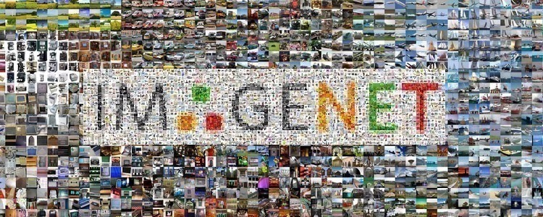

Figure 1. ImageNet Dataset

## COCO Dataset

The Microsoft Common Objects (MS COCO) in Context dataset is a large-scale segmentation, key-point detection, object detection, and captioning dataset. The dataset consists of about 328K images.

In 2017 the training set was changed from 83K to 118K, and the validation et was changed from 41K to 5K. The new set uses the same annotations and images. There are four folders in it. training, validation, and testing for annotations.

COCO dataset is a 19.7 GB ZIP file which is too big. We tried to crop the unneeded classes, but the problem was that all images were in the same folder and not divided into classes. So, we tried to download specific classes and the captions are linked together through JSON files with URLs, so we can’t split it because image names are randomly chosen and not related to anything, but we couldn’t find a solution for this so we used it as it is with all the images.

The dataset has annotations for:

* Captioning: natural language descriptions of the pictures, each picture has 5 captions.
* Object detection: bounding boxes and per-instance segmentation masks with 80 object categories.
* Key points detection: containing about 200,000 images and 250,000 person instances labelled with key points (seventeen possible key points, such as left eye, right ankle, right hip, nose).
* Panoptic: entire scene segmentation, with a subgroup of 91 item categories (road, sky, grass, etc). and 80 thing groups (such as bicycle, human, elephant, etc).
* Stuff image segmentation - per-pixel segmentation masks with 91 various categories, (such as sky, grass, wall, etc).

We used Microsoft Common Objects (MS COCO) dataset to train the model because of the variety of outdoor and indoor objects in it, as shown in Figure2.

The dataset includes:

* 118287 images for training.
* 5000 images for validation.
* About 1.5 million object instances.
* 5 captions per image.
* 80 object categories

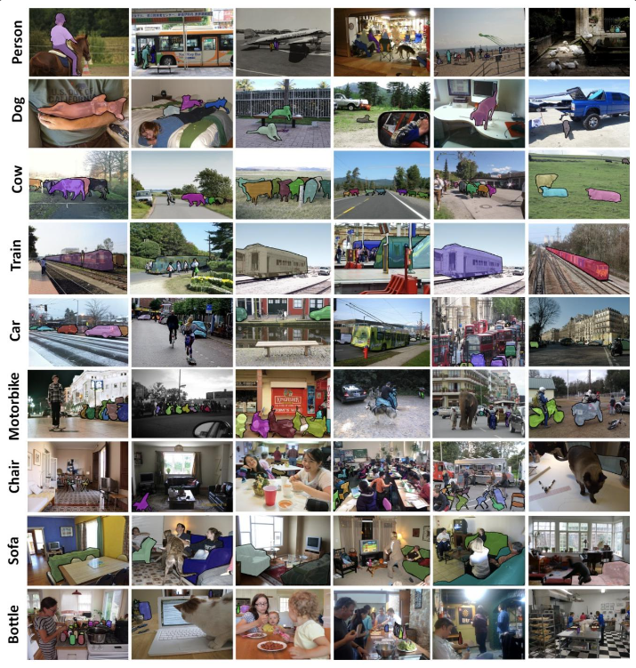

Figure 2. COCO Dataset

**Training:**

In Microsoft Common Objects (MS COCO) dataset it consists of about 118,000 images. The set of data that was used to train and fit the model

**Validation:**

In Microsoft Common Objects (MS COCO) dataset it consists of 5000 images, a subgroup of 91 item categories (road, sky, grass, etc). and 80 thing groups (such as bicycle, human, elephant, etc). The sample of data that used to fairly assess how well a model fits the training dataset while adjusting model hyperparameters.

**Testing:**

In Microsoft Common Objects (MS COCO) dataset it consists of about 40,700 images. The sample of data used to provide a fair evaluation of a final model fit on the training dataset.

## Why using COCO dataset?

Despite the problem we faced, we used it because it’s larger than flicker dataset and it has a variety of objects categorized by classes so we may use it for indoor objects or outdoor objects only or both. And to get a good model you need a large dataset to fed.

# Software

## Transfer Learning

Transfer learning is a machine learning method where a model developed for a task is reused as the starting point for a model on a second task.

It is a popular approach in deep learning where pre-trained models are used as the earliest point on natural language processing (NLP) and computer vision tasks given the wide compute and time resources required to enhance and develop neural network models on these problems and from the huge jumps in skill that they provide on related problems. It is flexible, allowing the use of pre-trained models directly, as feature extraction pre-processing and integrated into entirely new models.

In deep learning, transfer learning is a technique whereby a neural network model is first trained on a problem like the problem that is being solved. Several layers from the trained model are then used in a new model trained on the problem of interest.

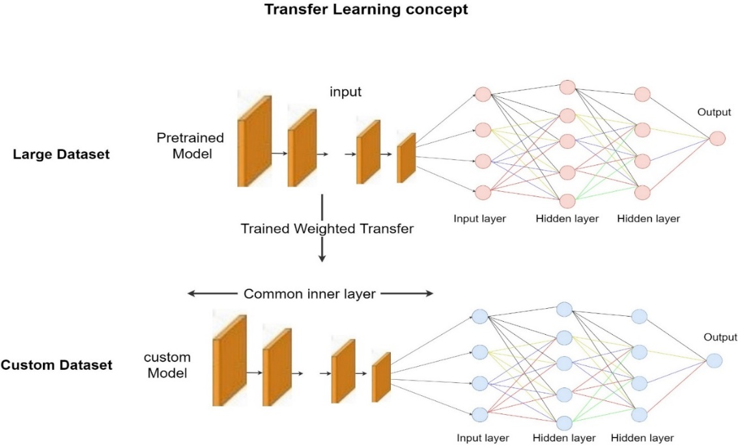Transfer learning has the advantage of reducing the training time for a neural network model and can result in lower generalization error, as shown in Figure 3.

Figure 3. Transfer Learning

## Convolutional Neural Networks

CNN is the class of deep neural networks generally applied for computer vision and image recognition. They are regularized versions of multilayer perceptron. Multilayer perceptron often means fully connected networks. For that reason, each neuron in one layer is connected to all neurons in the next layer. The "fully-connectedness" definition criteria of these networks make them prone and robust facing over fitting data. Standard ways of regularization include adding a form of magnitude measurement of weights to the loss function. On the other hand, CNNs provides a different approach and method regarding regularization: they take main advantage of the hierarchical pattern in data and assemble more complex patterns (often in the Dense Layers) using smaller and simpler patterns (extracted from the convolutional Layers).

The name “convolutional neural network” indicates reasonably that the network employs a mathematical operation called convolution which is a specialized kind of linear operation and matrix multiplications.

A CNN consists of an input and an output layer as well as multiple in-between hidden layers referred to as hidden layers simply because their inputs and outputs are masked by the activation function (commonly a ReLU layer subsequently followed by additional convolutions such as normalization layers, fully connected layers, pooling, and final convolution that usually involves backpropagation) as shown in Figure 4.

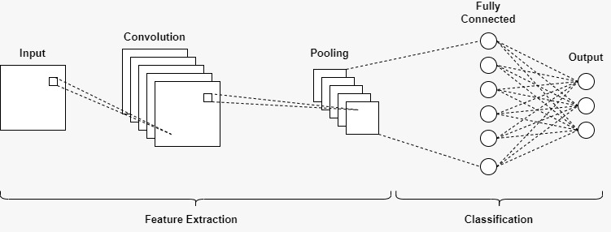

Figure 4. CNN Flowchart

## Different Types of CNN Architectures

### VGG16

VGG-16 is a convolutional neural network that is sixteen layers deep. You can load a pre-trained version of the network trained on about million images from the ImageNet database. The pre-trained network can classify images into 1000 object categories, such as mouse, keyboard, pencil, and animals.

The input image dimensions (224, 224, 3). The first two layers have the same padding and 64 channels of a (3*3) filter size. After a max pool layer of stride (2, 2), two layers have convolution layers of filter size (3, 3) and 256 filter size. This is followed by a max pooling layer of stride (2, 2) which is the same as the preceding layer. Then there are two convolution layers of filter size (3, 3) and 256 filters. After that, there are two sets of three convolution layers and a max pool layer. Each one has 512 filters of (3, 3) size with the same padding. This picture is then passed to the stack of two convolution layers. In these convolution and max pooling layers. In some layers, it also uses (1*1) pixel which is used to affect the number of input channels. There is a padding of 1-pixel (same padding) done after each convolution layer to block the spatial feature of the image, as shown in Figure 5.

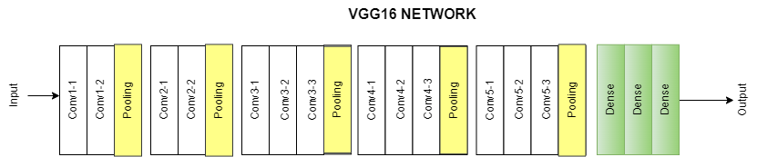

Figure 5. VGG16

### Inception V3 Model

The input image size of Inception-v3 is (299×299) and the image size in the dataset was (224×224).

Inception-V3 by Google is the third version in a series of Deep Learning Convolutional Architectures, and it is a widely used image recognition model that has been shown to obtain greater than 78.1% accuracy on the ImageNet dataset. Inception-V3 was trained using a dataset of 1,000 classes of the original ImageNet dataset, which was trained with about one million training images, the Tensorflow version has 1,001 classes which is an additional background class not used in the original ImageNet.

The model itself is made up of asymmetric and symmetric building blocks, including convolutions, average and max pooling, concats, dropouts, fully connected, Softmax layer, as shown in Figure 6.

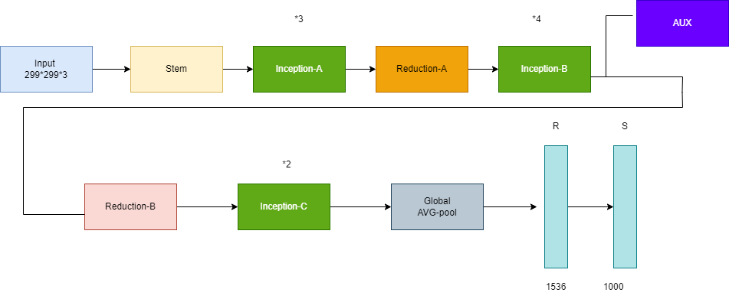

.

Figure 6. Inception V3

### VGG-19

VGG-19 is a convolutional neural network that is nineteen layers deep (sixteen convolution layers, three fully connected layer, five MaxPool layers and one SoftMax layer). You can load a pre-trained version of the network trained on about a million images from the ImageNet dataset. The pre-trained network can classify images into 1000 object categories, such as mouse, keyboard, pencil, and animals. As a result, the network has learned feature representations for a vast range of images. The network has an image input size (224*224), as shown in Figure 7.

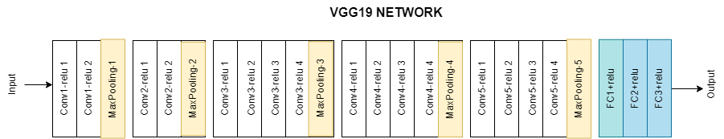

Figure 7. VGG19

### ResNet50

As shown in Figure 8, ResNet50 is a variant of ResNet Model which has 48 Convolution layers along with one MaxPool and one Average Pool layer. You can load a pre-trained version of the network trained about million images from the ImageNet dataset. The pre-trained network can classify images into 1000 object categories, such as mouse, pencil, keyboard, and animals, etc. As a result, the network has learned feature representations for a vast range of images. The network can take the input image having width, height as multiples of 32 and three as channel width. The input size is considered as (224*224*3), as shown in Figure 8.

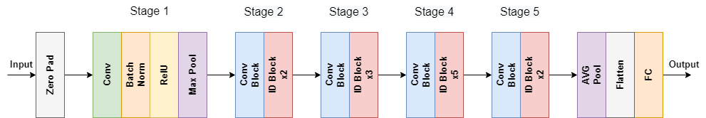

Figure 8. ResNet50

## Recurrent Neural Networks

A recurrent neural network (RNN) is a type of artificial neural network which uses time series data or sequential data. These deep learning algorithms are generally used for temporal problems, such as natural language processing (NLP), speech recognition, image captioning and language translation; they are incorporated into popular applications such as Siri Google Translate and voice search. Like convolutional neural networks (CNNs), recurrent neural networks utilize training data to learn. They are outstanding by their memory as they take information from prior inputs to affect the current input and output. While traditional deep neural networks suppose that inputs and outputs are independent of each other, the output of recurrent neural networks based on the prior elements within the sequence. While future events would also be helpful in setting the output of a given sequence, unidirectional recurrent neural networks cannot account for these events in their predictions.

## LSTM

Long short-term memory (LSTM) is an artificial neural network used in the fields of deep learning and artificial intelligence. Networks may be the most successful RNN’s as they let us to encapsulate a wider sequence of words or sentences for prediction. A common LSTM unit consists of a cell, an input, output and a forget gate. The cell remembers values over time intervals and the 3 gates regulate the flow of information into and out of the cell, as shown in Figure 9.

## LSTM Applications

LSTM networks find useful applications in the following areas:

* Image captioning.
* Handwriting recognition.
* Machine translation.
* Language modelling.

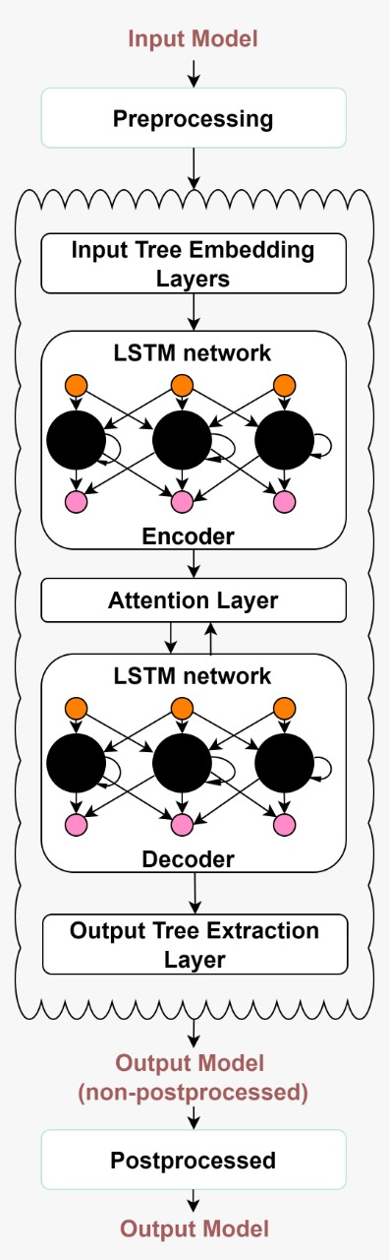

Figure 9. LSTM Model

## TensorFlow

TensorFlow is a software library created by Google to implement large scale machine learning models and to solve complex numerical problems. It became open source in 2015. The latest version 2.0 of TensorFlow includes many python APIs like Keras.

## Keras

Keras is a high-level deep learning API written by using python for neural networks. It has many pre-trained networks and uses a simple structure adapted to deep learning which provides a very easy and efficient tool for most Data Scientists and Machine Learning/Deep Learning engineers.

## Differences between Accuracy and loss in image captioning problem?

Accuracy vs Loss is usually neglected. People usually consider and care about the accuracy metric while model training. However, loss is something to be equally taken care of.

**Loss:** is the distance between your prediction and the actual.

**Accuracy:** is the number of errors or incorrect predictions you made.

All possible situations:

* Low accuracy and High loss = you aren't right often and when you're wrong you're very wrong (**worst case**)
* Low accuracy and Low loss = you aren't right often but the rest are pretty close
* High accuracy and High loss = you are right a lot but the rest are not close
* High accuracy and Low loss = most of your predictions are correct and the rest aren't off by much (**best case**)

Loss values are the values indicating the difference from the desired target state(s).

Loss can be seen as a distance between the true values of the problem and the values predicted by the model. Greater the loss is, huger is the errors you made on the data.

Accuracy can be seen as the number of errors you made on the data. In our problem we are carrying a lot about the loss metric more than accuracy because the predicted captions don’t need to be exactly the same trained captions

But the predicted captions have to be close as possible to the trained captions.

# Decoding Types

In NLP language handling tasks such as captioning, summarization, and translation require a sequence of words

It is common for models developed for these types of problems to output a probability distribution over each word in the vocabulary for each word in the output sequence. It is then left to a decoder process to transform the probabilities into a final sequence of words.

Decoding the most likely caption sequence involves searching all the possible output sequences based on their possibility, the size of vocab is usually thousands of words or even millions of words. Therefore, the search problem is exponential in the length of the output sequence and is intractable (NP-complete) to search completely.

## Greedy search

A simple estimation is to use a greedy search that selects the word with the highest probability at each step in the output sequence. this algorithm has the advantage of being very fast, but the quality of the output tends to be far from optimal. Greedy searches choose just one candidate per step it may be optimal at the current step in the flow but as we move through the rest of the full caption, it may turn to be worse than we thought, as shown in Figure 10.

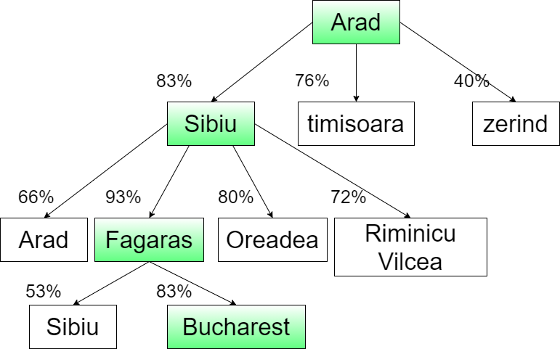

Figure 10. Greedy Search

## Beam search

Another heuristic is the beam search which expands the greedy search and returns a list of highest probability output sequences. Instead of choosing the word with the highest probability with greed as the sequence is being generated, at every step, all the successors of all the states are generated. the beam search expands all possible next steps and keeps the state with the highest probability.

The beam search selects multiple tokens for a position in a given sequence based on conditional probability. The algorithm can take any number of best alternatives through a hyperparameter known as Beam width. In greedy search, we simply take the best word for each position in the sequence, where here we expand our width to include other words that might fit better.

Beam search doesn't have to be used for sequence-based models where we use encoders and decoders to build large text and audio systems. Beam search can be broken down to a graph search where the points are possible are tokens in the input and we order all partial solutions according to some optimization function. Beam search builds its search tree using breadth-first search where the lower leaves of any given leaf are all possible states past the current leaf. We can use the beam width control how many leaves we can remove from the entire tree, where the higher a beam width the more leaves we leave and fewer are pruned. We can then use this as a breath-first search that uses the beam width as a memory control, in situations we want to account for run-time and tree size.

In terms of text sequence analysis like we saw above, a lower beam width will produce worse translations as the width moves towards 1 (which is the exact same as a Greedy Search) but becomes faster and more efficient. Many implementations start with a lower number for the beam width and progressively move it up as output results keep improving, as shown in Figure 11.

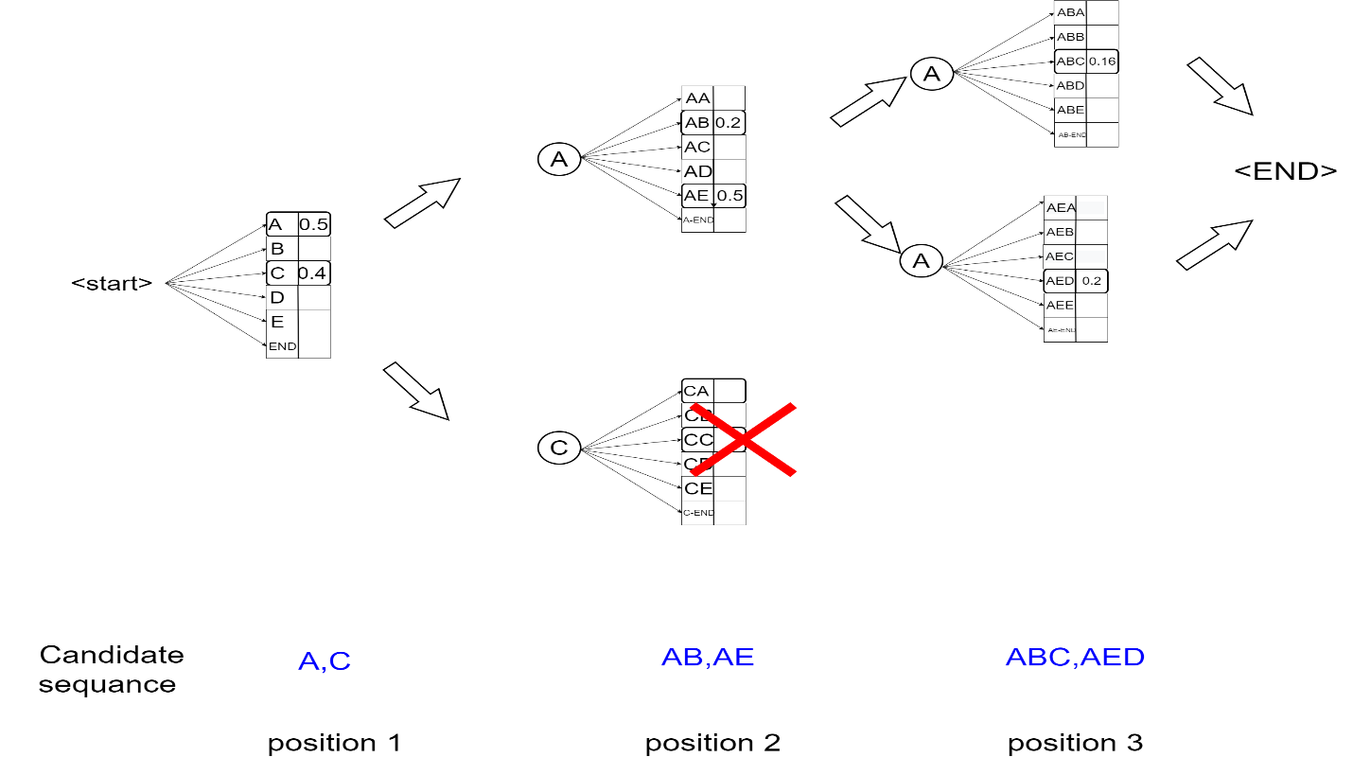

Figure 11 Beam Search

## Why greedy search is better than beam search in this project?

Beam search is better than greedy search as it generates more accurate results. However, we had to use greedy search because it is faster, and it generates probabilistic captions as a final output.

# Hardware

## Ultrasonic sensor

An ultrasonic sensor is an electronic device that measures the distance of a target object by emitting ultrasonic sound waves and converts the reflected sound into an electrical signal. Ultrasonic waves travel faster than the speed of audible sound (i.e. the sound that humans can hear). Ultrasonic sensors have two main components: the transmitter (which emits the sound using piezoelectric crystals) and the receiver (which encounters the sound after it has travelled to and from the target), as shown in Figure 12.

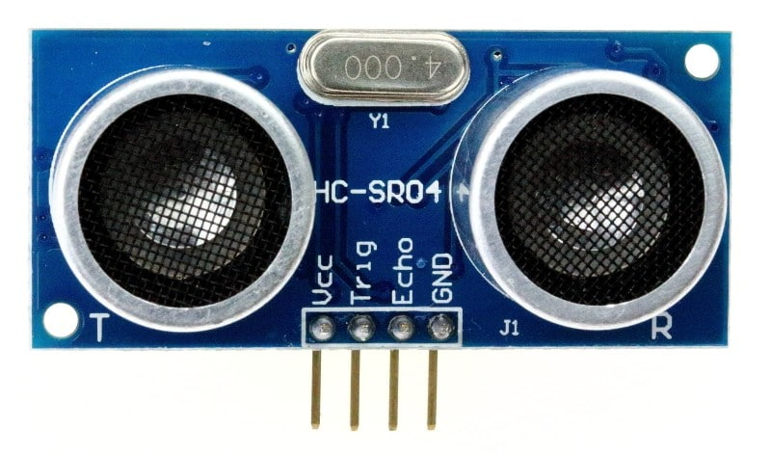

Figure 12. Ultrasonic

## Buzzer

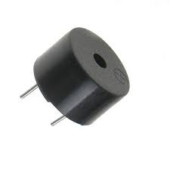An audio signaling device like a beeper or buzzer may be electromechanical or piezoelectric or mechanical type. The main function of this is to convert the signal from audio to sound. Generally, it is powered through DC voltage and used in timers, alarm devices, printers, alarms, computers, etc. Based on the various designs, it can generate different sounds like alarm, music, bell & siren as shown in Figure 13.

Figure 13. Buzzer

## Aurdino Nano

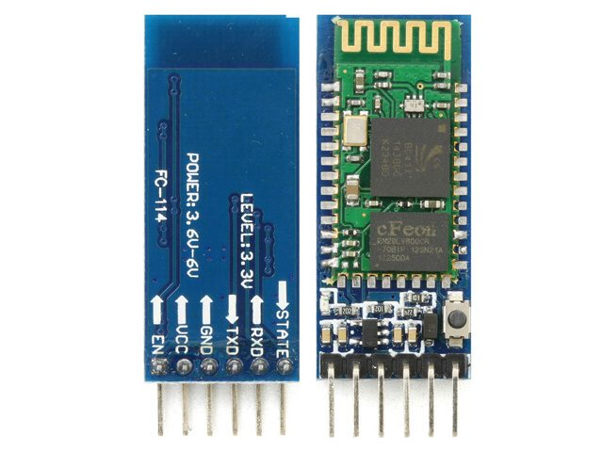Arduino is an open-source platform used for building electronics projects. Arduino consists of both a physical programmable circuit board (often referred to as a microcontroller) and a piece of software, or IDE (Integrated Development Environment) that runs on your computer, used to write and upload computer code to the physical board. The Arduino Nano is a small, complete, and breadboard-friendly board based on the ATmega328 (Arduino Nano 3.x). It has more or less the same functionality of the Arduino Duemilanove, but in a different package. It lacks only a DC power jack and works with a Mini-B USB cable instead of a standard one, as shown in Figure 14.

Figure 14. Arduino Nano

## HC-05 Bluetooth Module

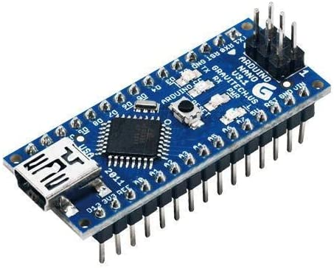HC-05 Bluetooth Module is an easy-to-use Bluetooth SPP (Serial Port Protocol) module, designed for transparent wireless serial connection setup. Its communication is via serial communication which makes an easy way to interface with controller or PC. HC-05 Bluetooth module provides switching mode between master and slave mode which means it able to use neither receiving nor transmitting data, as shown in Figure 15.

Figure 15. HC-05 Bluetooth Module

Chapter Four

System Overview

# System Architecture

The application is developed using JAVA native language. It is installed on the user’s mobile phone. When it is opened, it captures images automatically. Then, the captured image is transferred to the model using the API. The model detects and recognizes all the objects/places in the image and generates a description of it. The description then is converted to speech. Finally, the user receives the output as a voice message, as shown in Figure 16.

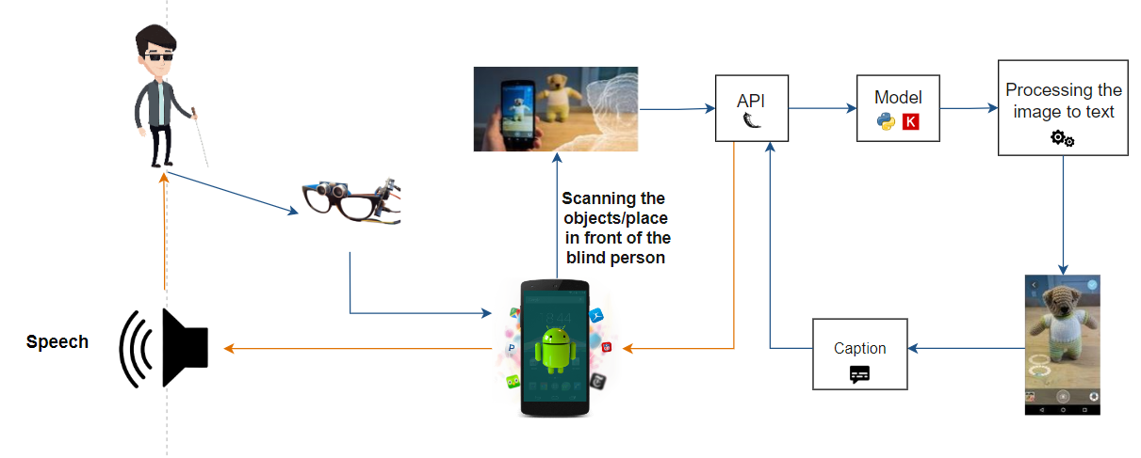

Figure 16 System Architecture

# Application Life cycle

When the user opens the application, it will open on camera automatically and capture an image then the application will encode the image to **Base64** string type through an HTTP request to the model API then we will handle this request in the API and decode the image to NumPy array and scaling the image to the desired input shape using flask framework then the model will predict the image caption and respond the caption as a JSON response. the application will receive this response and pronounce the text to the user by using Google API TextToSpeech. Then the cycle will be repeated, as shown in Figure 17.

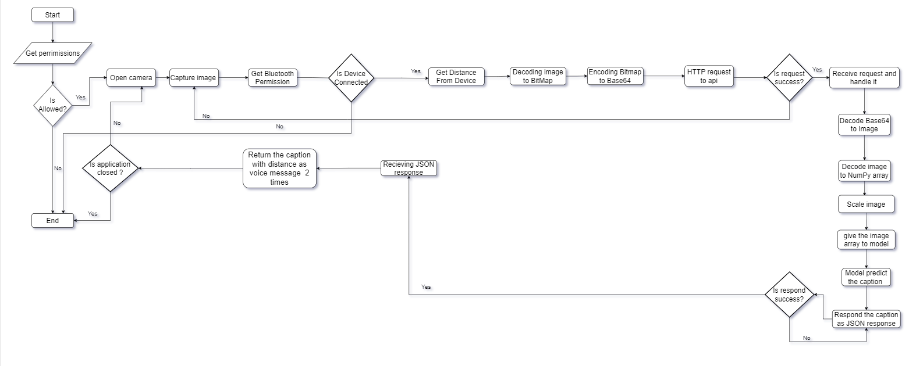

Figure 17 Application Life Cycle

# System Models

## Software architecture pattern

An **Architectural pattern** is a broad, repeatable response to a recurrent issue in software design within specific context Architectural patterns are like software design patterns but have a broader scope.

Types of Software architecture patterns:

* Model–view–presenter (MVP).
* Model-view-controller (MVC) Pattern.
* Model-View-ViewModel (MVVM).

### What is MVP?

By separating the presentation layer from the logic, the MVP pattern enables the UI to function regardless of how it is displayed on the screen. The MVP pattern seeks to create the possibility of totally distinct and interchangeable views for the same logic.

### What is MVC?

MVC Architecture pattern is a way how the information or data has been presented to the user & how the user interacts/deals with the data view.  
Every development process, including web development and the creation of portable apps for Android and iOS, uses an MVC framework.

MVVM consists of:

* **Model**

The model stores data and related logic. It represents information that is being transmitted between controller elements or any other relevant business logic.

* **View**

The view is the structure layout and look of what a user sees on the screen, same as in the model-view-controller (MVC) and model-view-presenter (MVP) patterns.

* **View Model**

The view model is responsible for presenting functions, commands, and methods, to support the state of the View. It is also accountable to operate the model and activating the events in the View.

### Why use MVVM instead of using MVC and MVP?

MVVM is the most common design pattern in android development, MVVM suggests separating the data presentation logic (Views or UI) from the core business logic part of the application. The view-model uses the observer pattern to modify the view-model. The MVVM pattern, which arose after MVC and MVP, is similar to an improved version of these two, as shown in Figure18.

MVVM Benefits:

* Easy to maintain and test.
* More Secure.
* Easier parallel development.
* Code reuse.

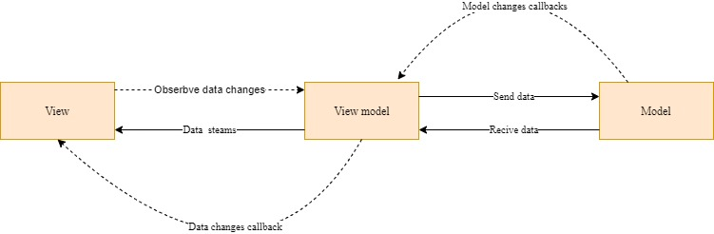

Figure 18. MVVM

# Use Case Diagram

Here is a representation of how our system works using use case diagram:

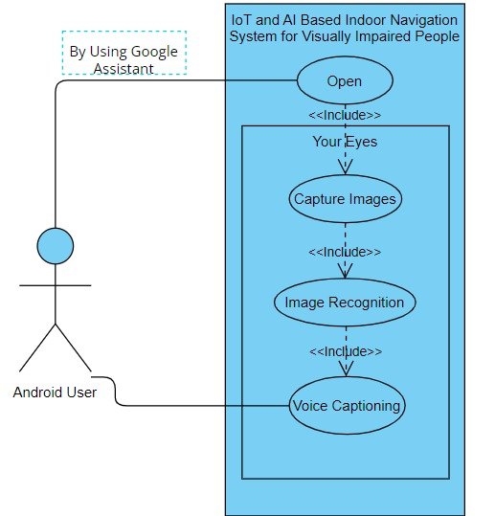

Figure 19 Use Case Diagram

Chapter Five

System Implementation

# User Interface

At first, we used ionic to make the mobile app, but we had a problem with using CameraX, CameraSelector is private in androidx.camera.core.CameraSelector. Can’t be accessed from the outside package. Another problem is that the preview is not fully displayed.

Another problem was ionic syntax. There are many libraries deprecated and syntax keeps changing after updates.

The images were supposed to be captured automatically but this could not be done in ionic because it is a framework, and it couldn’t access all the camera functions. To capture a photo, it had to be through user interaction by using a capturing button or volume buttons.

After learning about the native language, we used java as a native language for android to access all camera functions by using the Camera2 package.

By using google assistant the user can call our application with his voice without even touching the screen as shown in Figure 20.

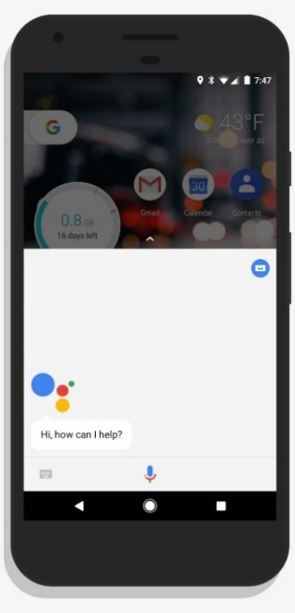

Figure 20 User interface

When opening the application for the first time it requests from you the permission to allow accessing your camera as shown in Figure 21.

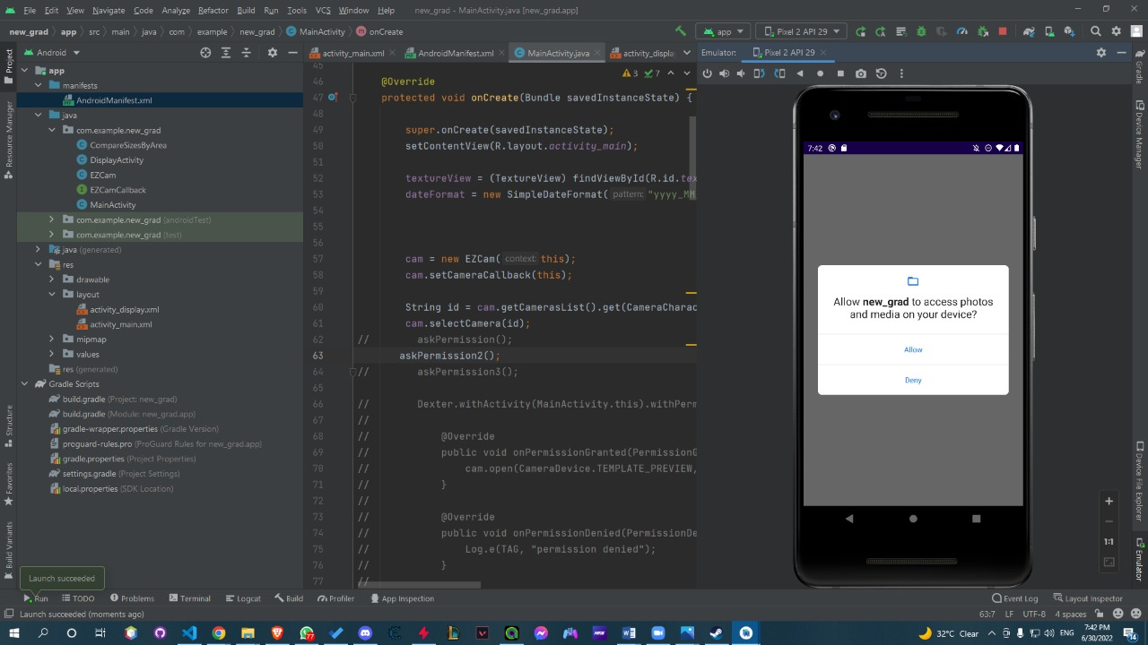

Figure 21 User interface

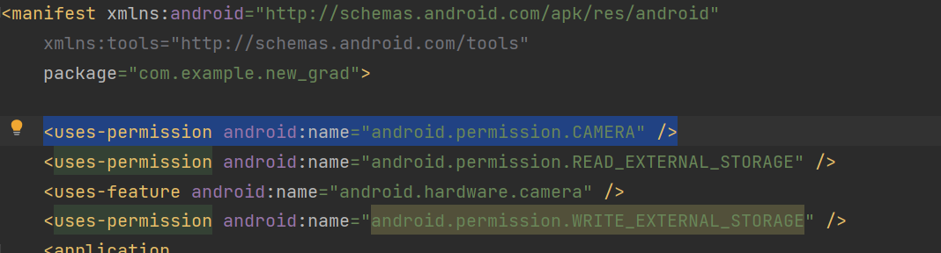The required permissions for protecting user’s privacy:

Figure 22 Android Permission Code

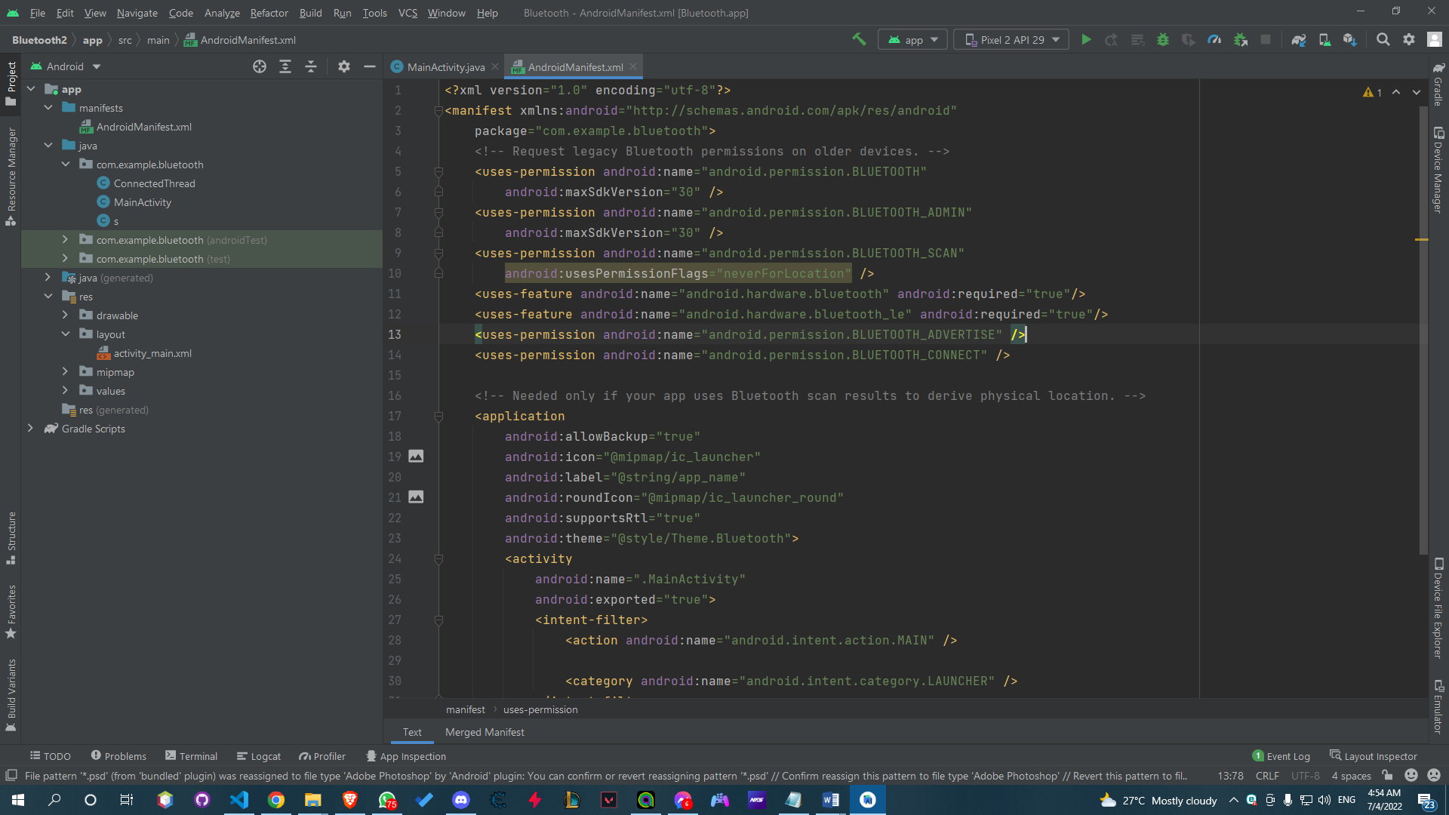

Figure 23 Android Permission Code

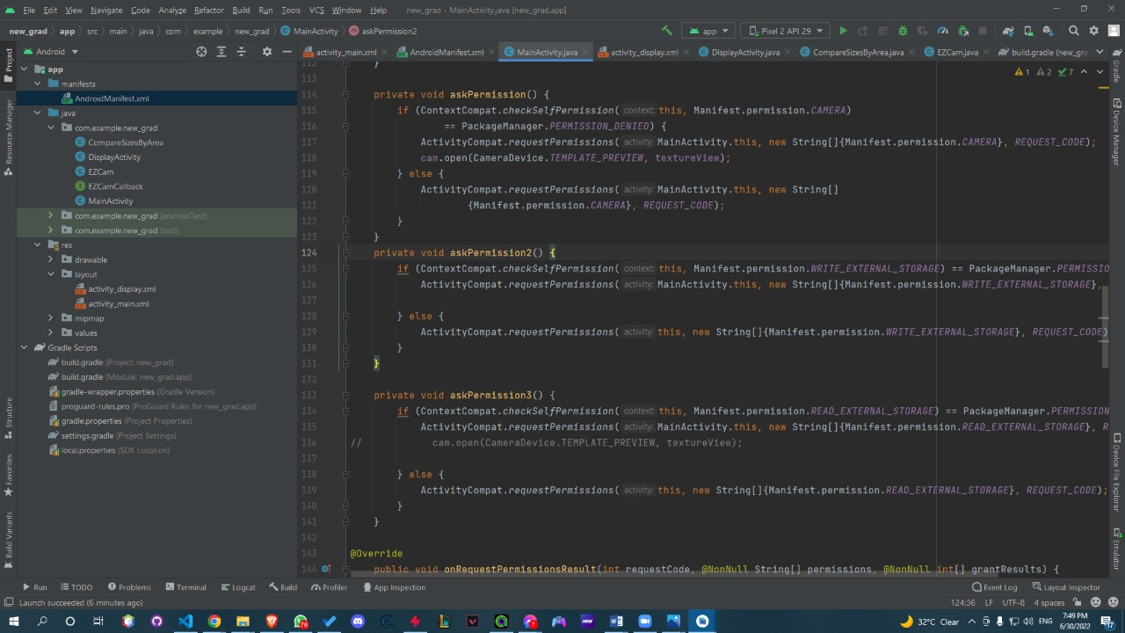

Figure 24 Android Permission Code

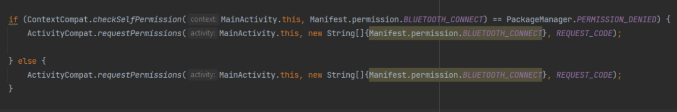

Figure 25 Android Permission Request

We wanted to use an external small camera and connect it to the mobile by a cable and both are put in his jacket. We couldn’t find that type of camera, we only found webcams so, we used the mobile camera.

Then, to make it easy for the user no need for buttons or anything it captures the image automatically as shown in Figure 26.

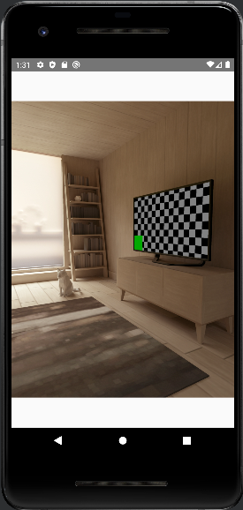

Figure 26 Camera Interface

By the function “CountdownTimer” Schedules a countdown until a time in the future which is 40 seconds in our case (40000 milliseconds) it waits for all functions to complete as shown in Figure 27.

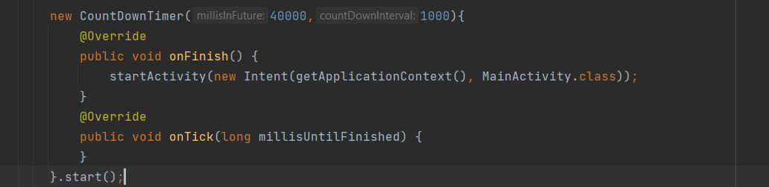

Figure 27 Countdown Timer

The output of the app will be an audio **(Google API TextToSpeech)** that describes the image. The app is designed to keep working and it doesn’t close if the user clicked the back/return button.

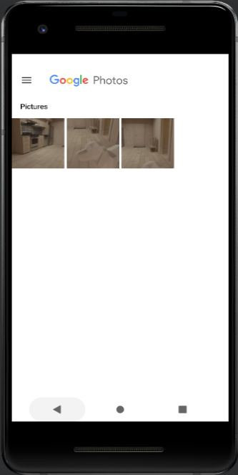We faced a challenge with saving images on the device. The app worked successfully on the emulator, but on the mobile, the images were not saved. This was solved after clearing data from storage and having enough space and images are saved in the gallery, then we decide not to save any images to phone storage because it will be a hundred of images and it will waste user storage as shown in Figure 28.

Figure 28 Phone Gallery

# Software Implementation

At first, we used a different model that works with VGG16 and RNN:

|  |  |
| --- | --- |
| In this model, we used COCO dataset because it has five captions per image which is an important feature. The image caption is automatically generating natural language descriptions according to the content observed in an image. It also recognizes the context of an image and annotates it with relevant captions using deep learning. |  |

We had a problem with calculating the accuracy. Every time we try to calculate it, we get a Resource Exhausted Error, and we could not solve this problem, so we used another model.

Not all datasets can work with all models, but each dataset requires a specific model that will fit better than other models. For example, we are using COCO dataset. We tried many models for images (VGG16, VGG19, and ResNet50) and for generating the text (RNN and LSTM). VGG19 was a bad option as most of the outputs generated were wrong. VGG16 was better than VGG19 but ResNet50 with LSTM was the best for this problem.

## Image Captioning

Describing a picture is the issue of creating a written description of an image that is legible by humans, such as a picture of an object or scene. It integrates natural language processing with computer vision.

There are two fundamental components to neural network captioning models:

1. Feature Extraction (CNN).
2. Language Model (LSTM).

## The CNN-LSTM Model

The combination of many network types into hybrid models yields one of the most interesting and practically relevant neural models.

The RGB image tensor cannot be entered directly because the system is not designed to handle such inputs. Images are an example of input having spatial structure that is difficult to model with the Vanilla LSTM.

The image's features can be extracted using the deep CNN architecture and then input into the LSTM architecture to produce the caption.

In this design, feature extraction from input data is done using Convolutional Neural Network (CNN) layers, and sequence prediction is done using LSTMs on the feature vectors. In essence, CNN LSTMs are subset of models that are both temporarily and spatially deep and reside at the intersection of computer vision and natural language processing. These models have a huge amount of potential and are being used more frequently for a variety of challenging tasks, like video conversion, text classification, and other similar ones. Here is a typical CNN LSTM model architecture as shown in Figure 29, 30.

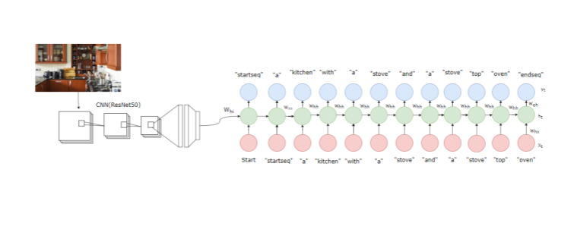

Figure 29 CNN-LSTM Architecture

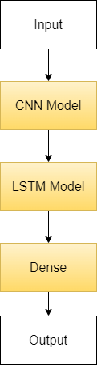

Figure 30 CNN-LSTM Model

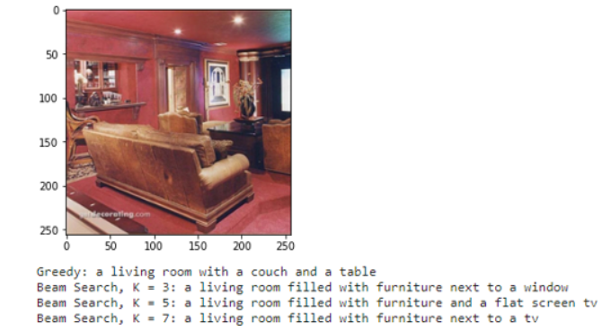

Figure 31 Image Captioning Result

### Encoder

One might imagine the Convolutional Neural Network (CNN) as an encoder CNN is given the input image to extract the features. The Decoder is linked to the CNN's last hidden state.

### Decoder

The Decoder is a recurrent neural network (RNN) that model’s language up to the word level. The first-time step receives the encoded output from the encoder and the <START> vector.

### Training

The first-time step of the decoder receives the output from the CNN's last hidden state (encoder). We set x1 =<START> vector and the desired label y1 = first word in the sequence. Similar to this, we expect the network to predict the second word by setting x2 = word vector of the first word. Finally, on the last step, xT = last word, the target label yT =<END> token. Even if the decoder made a mistake before, the correct input is always provided to the decoder throughout training.

### Testing

The image representation is fed into the decoder's initial time step. Set x1 =<START> vector and compute the distribution over the first word y1. We sample a word from the distribution (or pick the argmax), set its embedding vector as x2, and repeat this process until the <END> token is generated.During Testing, the output of the decoder at time t is fed back and becomes the input of the decoder at time t+1.

### Image pre-processing

Image pre-processing are the steps taken to format images before they are used by model training, pre-processing is required to clean image data for model input. For example, fully connected layers in convolutional neural networks required that all images are the same sized arrays, First thing to do is to resize the image size to fit in the input shape of deep learning model, then convert this image to NumPy array to deal with these pixels as numbers, then expand the shape of array then the last step is to utilize preprocess_input() capability to sufficient your picture to the configuration/format the model requires Some models use pictures with values going from 0 to 1. Others from - 1 to +1. Others utilize the "caffe" style, which isn't normalized, but is centered.

preprocess_input():

returns the images converted from RGB to BGR, then each color channel is zero-centered with respect to the ImageNet dataset, without scaling.

### Read images

We saved the path to our image dataset in a variable and then wrote a function to load folders containing images into arrays.

### Text Pre-processing

Clean description text by

* Remove punctuation

By using the str.translate() method. The translate method typically takes a translation table, which we’ll do using the maketrans() method.

* Lowercase all words

By using lower() function It converts all uppercase characters to lowercase.

# Hardware Implementation

We used a simple embedded system to measure the distance to alert the user if he is too close to obstacle, we build our embedded system on glasses to make it easy to wear for users and make it simple as possible to make the user who setup the app for blind person be easy as possible.

Components and supplies we used in this project, as shown in Figure 32, 33 and 34:

* Ultrasonic sensor
* Buzzer
* Arduino Nano
* FF Wires
* 12V Battery
* HC-05 Bluetooth Module
* Glue gun
* 3D glasses

## Circuit Design

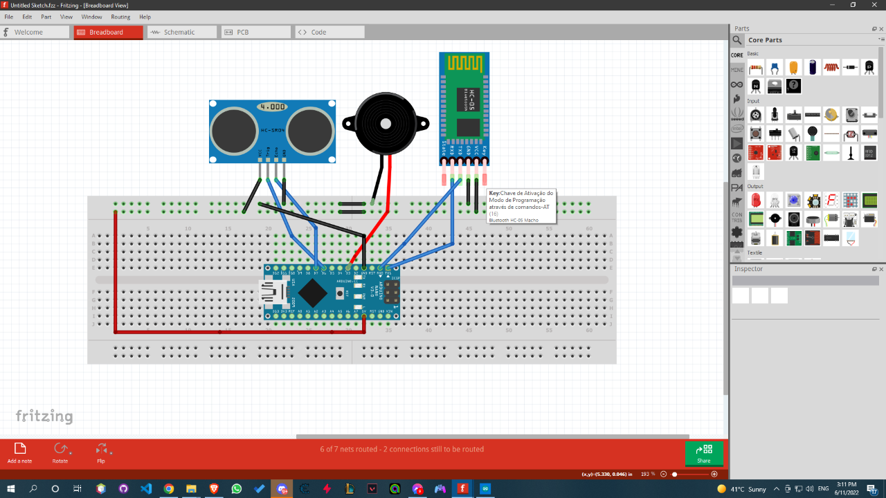

Figure 32 Circuit Design

## Circuit Implementation

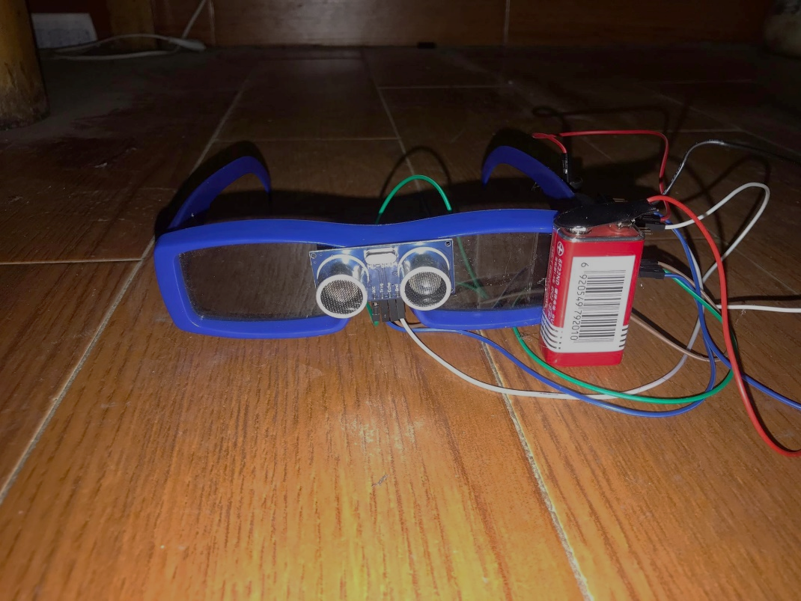

Figure 33 Circuit Implementation on glasses

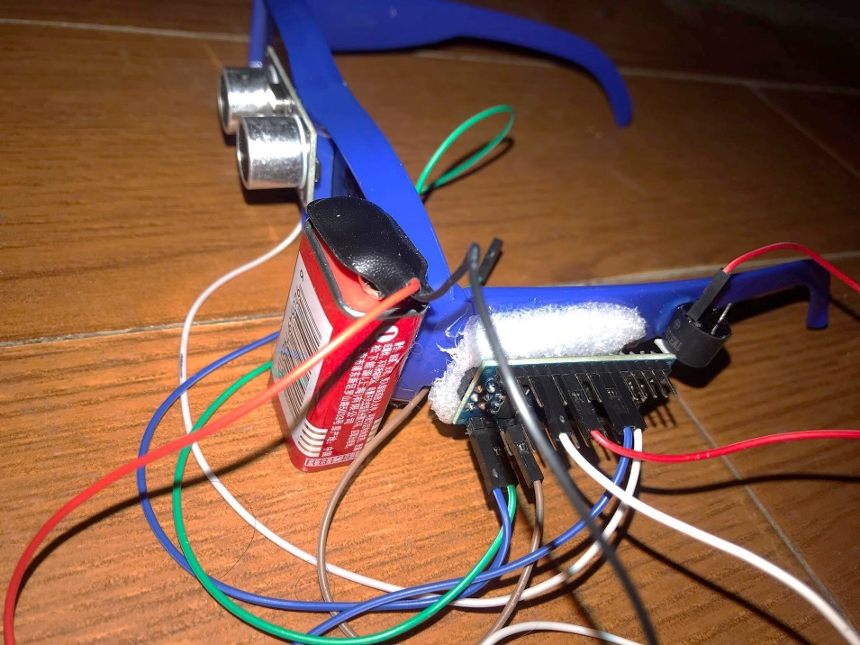

Figure 34 Circuit Implementation on glasses

# System Deployment

At first, the photo will be captured and then saved in the drawable file then the photo path will be sent to the next activity and load it from the drawable file after that the photo will be transformed into a bitmap format the bitmap will be transformed into base64 format to be sent as a string to the API as a post request.

after the base64 string is sent to the API it will be transformed back to a Bitmap image then the image will be reshaped into the desired size, then the API will classify the photo using the dl model. And the image caption prediction algorithms will start which are greedy search and beam search algorithms

greedy search works by choosing the best possible word in each step and then moving on to the next step until it reaches the end, with no regard for what the final solution will be.

While beam search works by selecting multiple tokens for a position in a given sequence based on conditional probability. The algorithm can take any number of N best alternatives through a hyperparameter known as Beam width.

And then the API will compute the BLEU score for the caption to see which caption is more accurate.

After the most accurate caption is computed the caption will be sent back to the mobile app as a response then the caption will return to the user as a voice message by using google speech API.

Then the app will wait 30 seconds and then the app will automatically open the camera activity and capture another photo then the steps will be repeated again and again until the user closes the application.

Chapter Six

Experimental Results & Graphs

# VGG16 Results

Here we experiment VGG16 model which is a type of CNN that is trained on COCO dataset to extract features from images with 40 Epochs, 47.12% accuracy, 2.3718 loss, and the results as shown in figures 35,36,37 and 38:

Table 1 VGG16 Results

|  |  |  |  |  |  |  |  |  |  |  |  |  |  |  |  |  |  |  |  |  |  |  |  |  |  |  |  |  |  |  |  |  |  |  |  |  |  |  |  |  |  |  |  |  |  |  |  |  |  |  |  |  |  |  |  |  |  |  |  |  |  |  |  |
| --- | --- | --- | --- | --- | --- | --- | --- | --- | --- | --- | --- | --- | --- | --- | --- | --- | --- | --- | --- | --- | --- | --- | --- | --- | --- | --- | --- | --- | --- | --- | --- | --- | --- | --- | --- | --- | --- | --- | --- | --- | --- | --- | --- | --- | --- | --- | --- | --- | --- | --- | --- | --- | --- | --- | --- | --- | --- | --- | --- | --- | --- | --- | --- |
| |  |  |  | | --- | --- | --- | | Epoch 20/40  1848/1848 | loss: 2.4146 | accuracy: 0.4666 | | Epoch 21/40  1848/1848 | loss: 2.4108 | accuracy: 0.4670 | | Epoch 22/40  1848/1848 | loss: 2.4072 | accuracy: 0.4675 | | Epoch 23/40  1848/1848 | loss: 2.4043 | accuracy: 0.4678 | | Epoch 24/40  1848/1848 | loss: 2.4008 | accuracy: 0.4680 | | Epoch 25/40  1848/1848 | loss: 2.3979 | accuracy: 0.4686 | | Epoch 26/40  1848/1848 | loss: 2.3959 | accuracy: 0.4687 | | Epoch 27/40  1848/1848 | loss: 2.3940 | accuracy: 0.4690 | | Epoch 28/40  1848/1848 | loss: 2.3911 | accuracy: 0.4692 | | Epoch 29/40  1848/1848 | loss: 2.3892 | accuracy: 0.4694 | | Epoch 30/40  1848/1848 | loss: 2.3880 | accuracy: 0.4696 | | Epoch 31/40  1848/1848 | loss: 2.3860 | accuracy: 0.4695 | | Epoch 32/40  1848/1848 | loss: 2.3834 | accuracy: 0.4699 | | Epoch 33/40  1848/1848 | loss: 2.3822 | accuracy: 0.4700 | | Epoch 34/40  1848/1848 | loss: 2.3801 | accuracy: 0.4702 | | Epoch 35/40  1848/1848 | loss: 2.3788 | accuracy: 0.4706 | | Epoch 36/40  1848/1848 | loss: 2.3776 | accuracy: 0.4708 | | Epoch 37/40  1848/1848 | loss: 2.3766 | accuracy: 0.4708 | | Epoch 38/40  1848/1848 | loss: 2.3747 | accuracy: 0.4712 | | Epoch 39/40  1848/1848 | loss: 2.3742 | accuracy: 0.4711 | | Epoch 40/40 | loss: 2.3718 | accuracy: 0.4712 | |
|  |
| Graphical user interface, application  Description automatically generated  Figure 35 Plot Training Accuracy for Proposed Model |

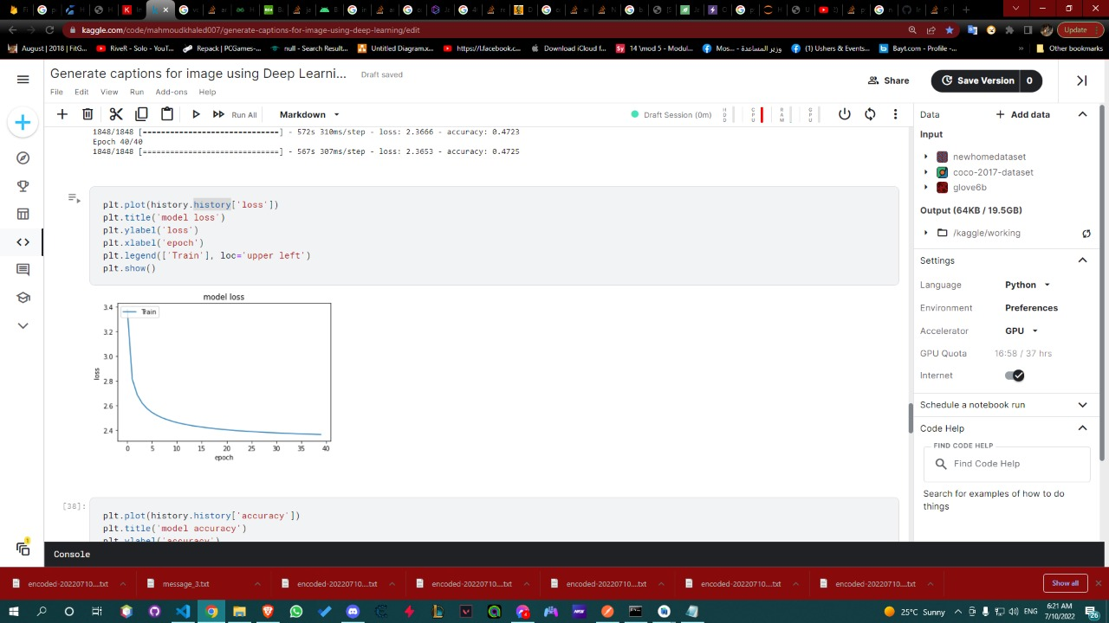

Figure 36 Plot Training Loss for Proposed Model

|  |
| --- |
| Figure 37 VGG16 Prediction Example |
| Figure 38 VGG16 Prediction Example |

# VGG19 Results

Here we experiment VGG19 model which is a type of CNN that is trained on COCO dataset to extract features from images with 40 Epochs, 47.62% accuracy, 3.3310 loss, and the results as shown in figures 39,40,41 and 42:

Table 2 VGG19 Results

|  |  |  |  |  |  |  |  |  |  |  |  |  |  |  |  |  |  |  |  |  |  |  |  |  |  |  |  |  |  |  |  |  |  |  |  |  |  |  |  |  |  |  |  |  |  |  |  |  |  |  |  |  |  |  |  |  |  |  |  |  |
| --- | --- | --- | --- | --- | --- | --- | --- | --- | --- | --- | --- | --- | --- | --- | --- | --- | --- | --- | --- | --- | --- | --- | --- | --- | --- | --- | --- | --- | --- | --- | --- | --- | --- | --- | --- | --- | --- | --- | --- | --- | --- | --- | --- | --- | --- | --- | --- | --- | --- | --- | --- | --- | --- | --- | --- | --- | --- | --- | --- | --- |
| |  |  |  | | --- | --- | --- | | Epoch 21/40  924/924 | loss: 2.3836 | accuracy: 0.4704 | | Epoch 22/40  924/924 | loss: 2.3787 | accuracy: 0.4708 | | Epoch 23/40  924/924 | loss: 2.3745 | accuracy: 0.4714 | | Epoch 24/40  924/924 | loss: 2.3718 | accuracy: 0.4717 | | Epoch 25/40  924/924 | loss: 2.3676 | accuracy: 0.4718 | | Epoch 26/40  924/924 | loss: 2.3647 | accuracy: 0.4723 | | Epoch 27/40  924/924 | loss: 2.3610 | accuracy: 0.4727 | | Epoch 28/40  924/924 | loss: 2.3572 | accuracy: 0.4733 | | Epoch 29/40  924/924 | loss: 2.3549 | accuracy: 0.4736 | | Epoch 30/40  924/924 | loss: 2.3530 | accuracy: 0.4739 | | Epoch 31/40  924/924 | loss: 2.3499 | accuracy: 0.4739 | | Epoch 32/40  924/924 | loss: 2.3469 | accuracy: 0.4744 | | Epoch 33/40  924/924 | loss: 2.3451 | accuracy: 0.4748 | | Epoch 34/40  924/924 | loss: 2.3425 | accuracy: 0.4748 | | Epoch 35/40  924/924 | loss: 2.3400 | accuracy: 0.4751 | | Epoch 36/40  924/924 | loss: 2.3380 | accuracy: 0.4754 | | Epoch 37/40  924/924 | loss: 2.3361 | accuracy: 0.4755 | | Epoch 38/40  924/924 | loss: 2.3341 | accuracy: 0.4759 | | Epoch 39/40  924/924 | loss: 2.3325 | accuracy: 0.4762 | | Epoch 40/40  924/924 | loss: 2.3310 | accuracy: 0.4762 | |
|  |

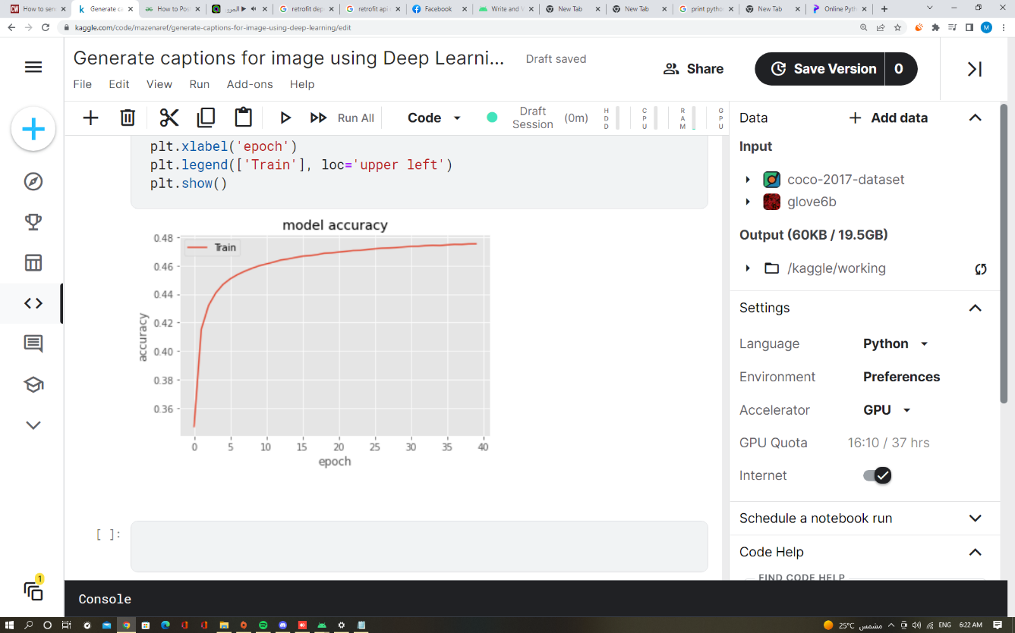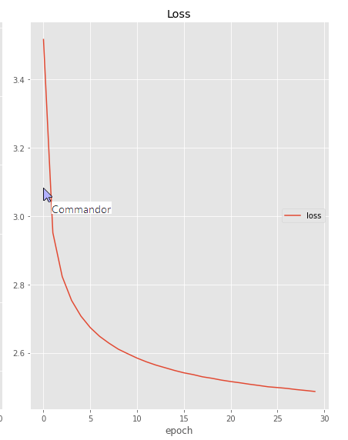

Figure 39 Plot Training Loss for Proposed Model

Figure 40 Plot Training Accuracy for Proposed Model

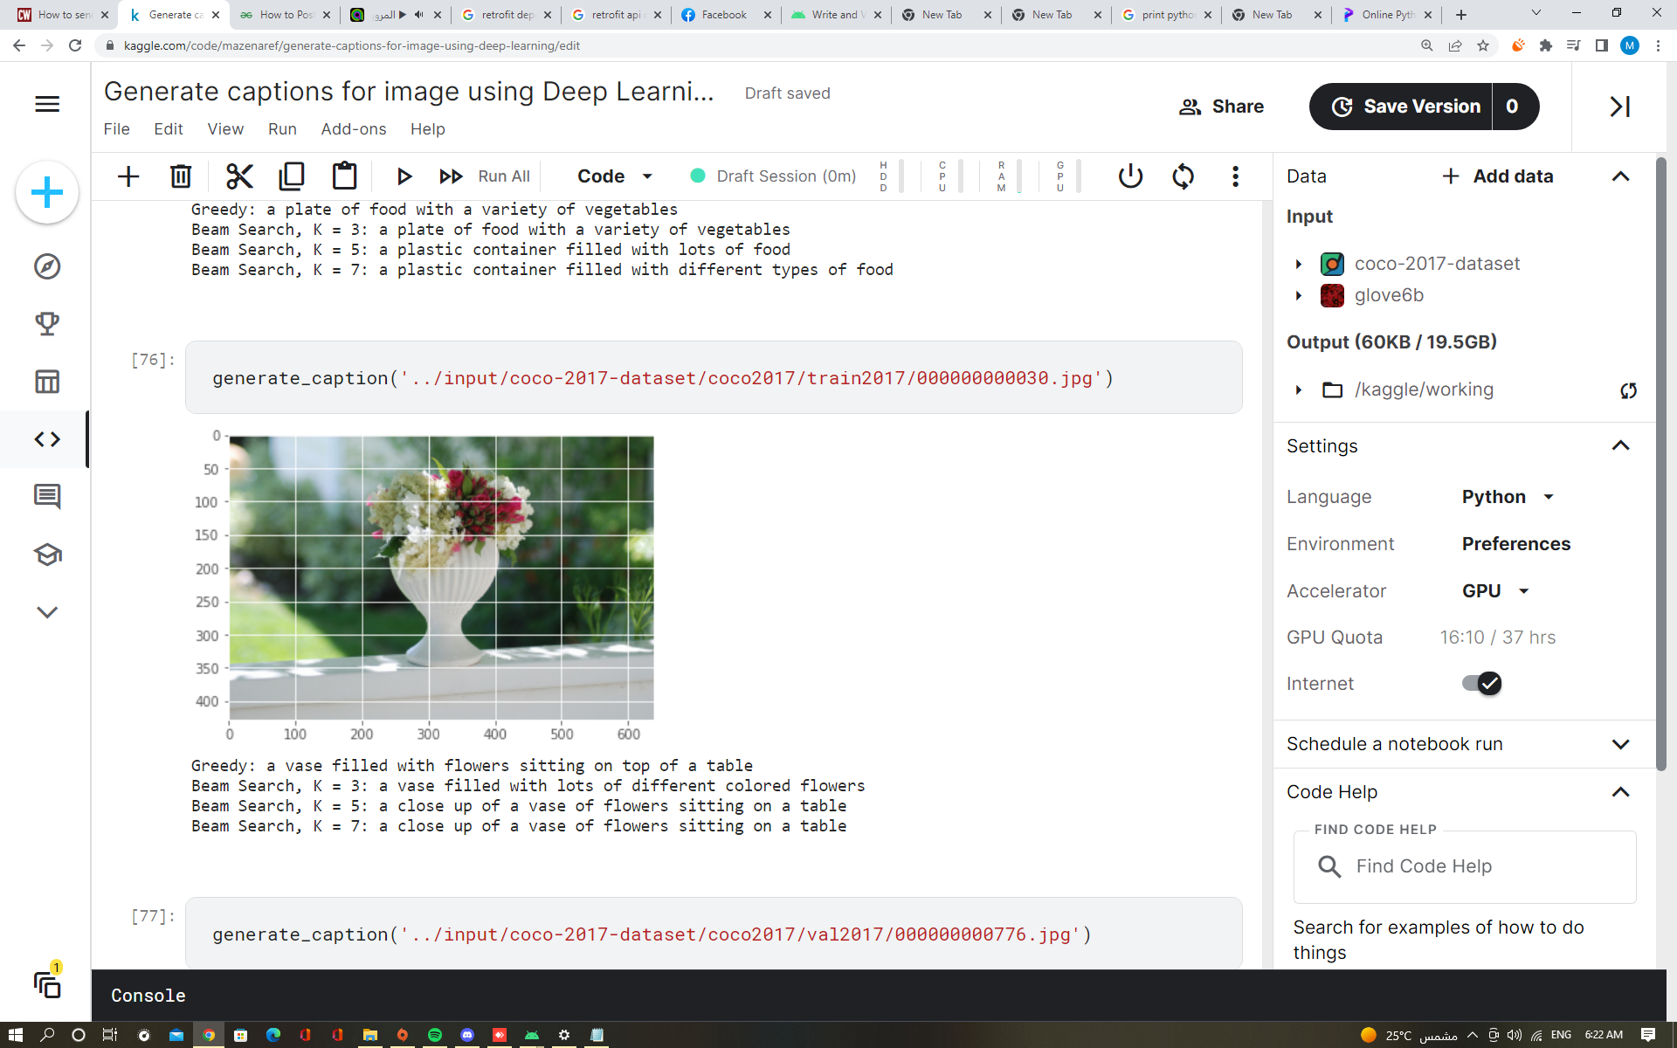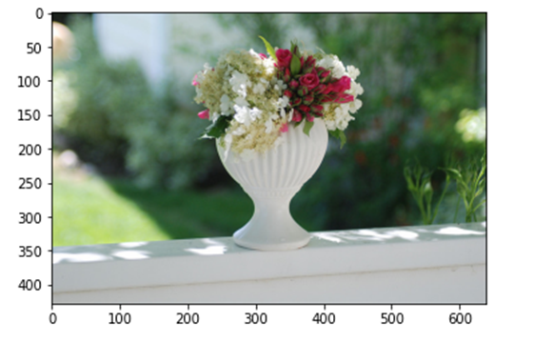

Figure 41 VGG19 Prediction Example

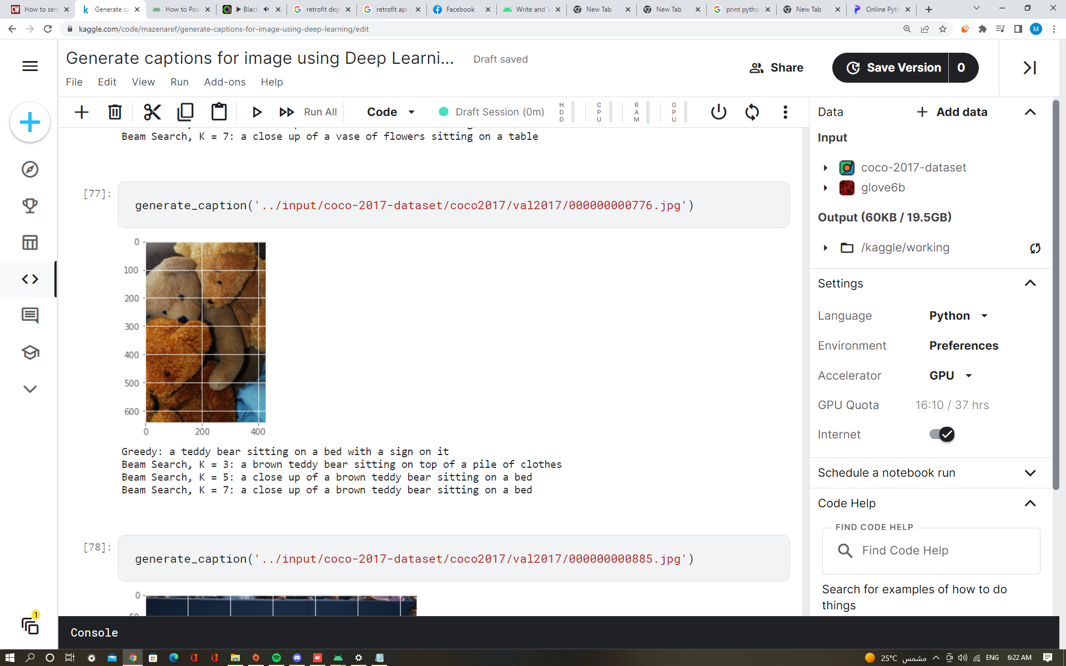

Figure 42 VGG19 Prediction Example

# Inception V3

Here we experiment Inception V3 model which is a type of CNN that is trained on COCO dataset to extract features from images with 20 Epochs, 47.20% accuracy, 2.3820 loss, and the results as shown in figures 43,44,45,46, and 47:

Table 3 Inception V3 Results

|  |  |  |  |
| --- | --- | --- | --- |
| Epoch 1/20  1848/1848 | loss: 3.3183 | accuracy: 0.3759 | |
| Epoch 2/20  1848/1848 | loss: 2.7886 | accuracy: 0.4298 | |
| Epoch 3/20  1848/1848 | loss: 2.6673 | accuracy: 0.4428 | |
| Epoch 4/20  1848/1848 | loss: 2.6007 | accuracy: 0.4499 | |
| Epoch 5/20  1848/1848 | loss: 2.5574 | accuracy: 0.4543 | |
| Epoch 6/20  1848/1848 | loss: 2.5258 | accuracy: 0.4574 | |
| Epoch 7/20  1848/1848 | loss: 2.5024 | accuracy: 0.4596 | |
| Epoch 8/20  1848/1848 | loss: 2.4827 | accuracy: 0.4617 | |
| Epoch 9/20  1848/1848 | loss: 2.4670 | accuracy: 0.4632 | |
| Epoch 10/20  1848/1848 | loss: 2.4534 | accuracy: 0.4646 | |
| Epoch 11/20  1848/1848 | loss: 2.4422 | accuracy: 0.4655 | |
| Epoch 12/20  1848/1848 | loss: 2.4321 | accuracy: 0.4665 | |
| Epoch 13/20  1848/1848 | loss: 2.4237 | accuracy: 0.4675 | |
| Epoch 14/20  1848/1848 | loss: 2.4156 | accuracy: 0.4686 | |
| Epoch 15/20  1848/1848 | loss: 2.4089 | accuracy: 0.4692 | |
| Epoch 16/20  1848/1848 | loss: 2.4025 | accuracy: 0.4698 | |
| Epoch 17/20  1848/1848 | loss: 2.3970 | accuracy: 0.4705 | |
| Epoch 18/20  1848/1848 | loss: 2.3916 | accuracy: 0.4711 | |
| Epoch 19/20  1848/1848 | loss: 2.3870 | accuracy: 0.4715 | |
| Epoch 20/20  1848/1848 | loss: 2.3820 | accuracy: 0.4720 | |
|  | | |
|  | | |
|  | | |
| Figure 43 Plot Training Accuracy for Proposed Model | | |

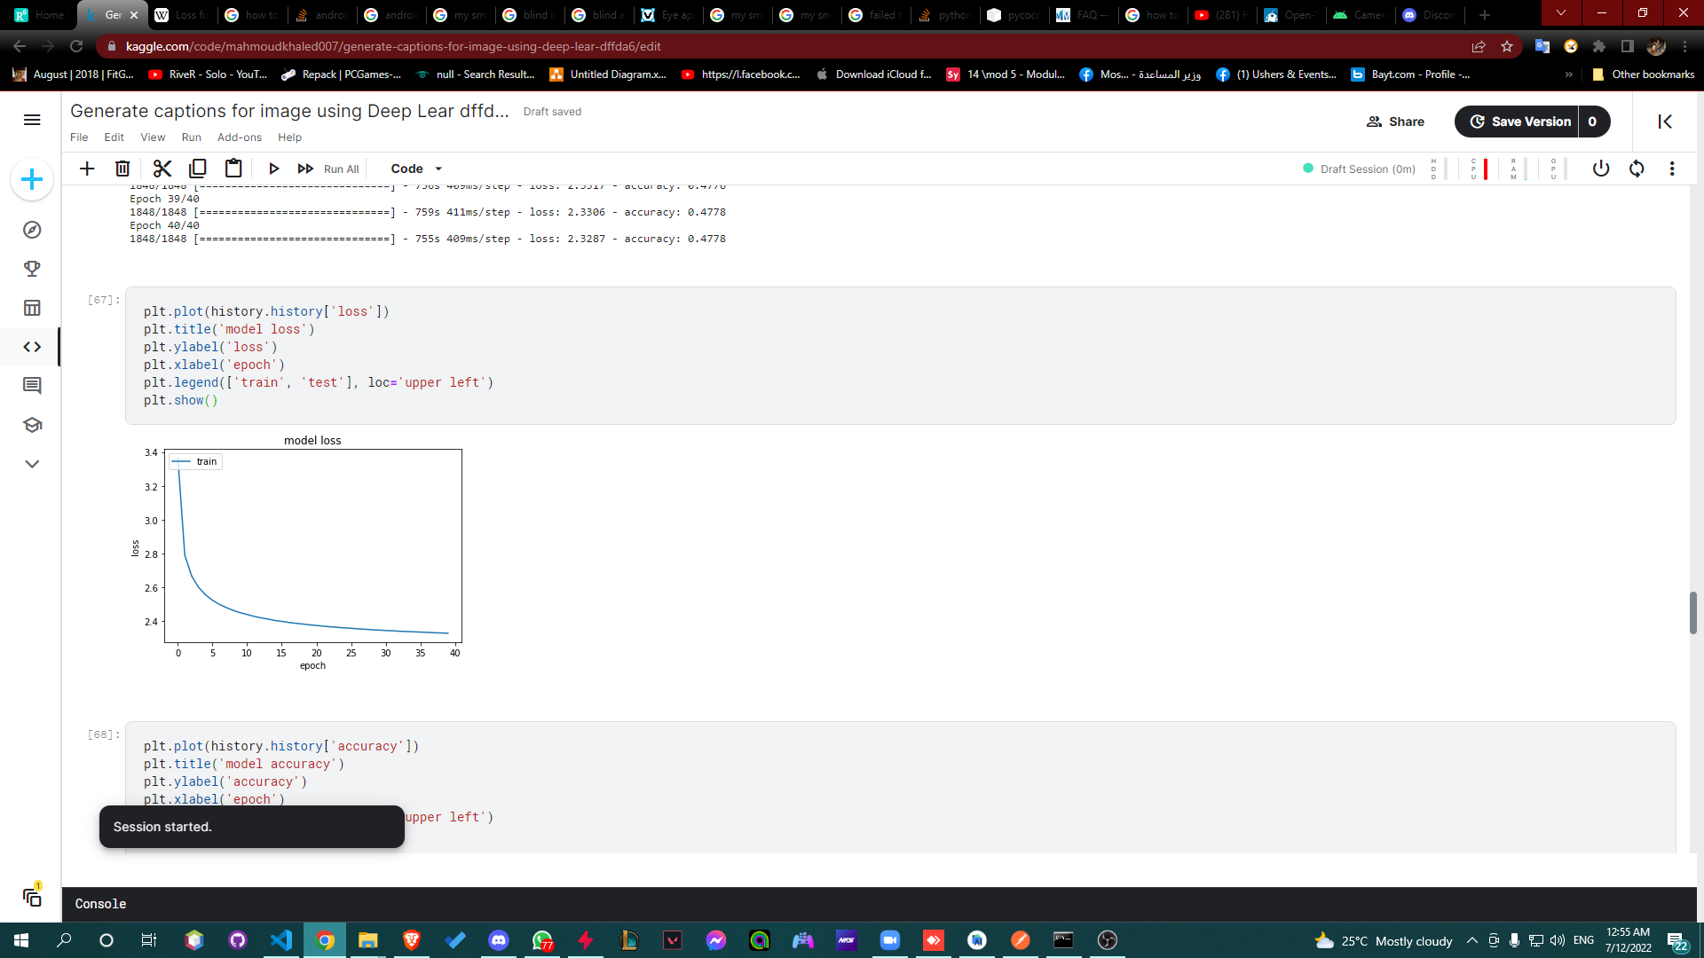

Figure 44 Plot Training Loss for Proposed Model

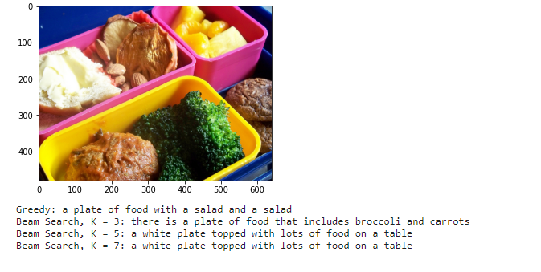

Figure 45 Inception V3 Prediction Example

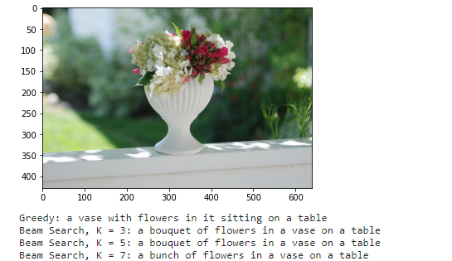



Figure 46 Inception V3 Prediction Example

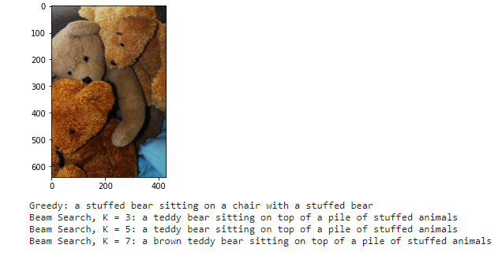



Figure 47 Inception V3 Prediction Example

# Keras

Here we looked at the model which Keras built for image captioning as we see we made a better result than them.

Table 4 Keras Example Results

|  |  |  |
| --- | --- | --- |
| Epoch 30/40  96/96 | loss: 14.8596 | accuracy: 0.4069 |
| Epoch 31/40  96/96 | loss: 14.3454 | accuracy: 0.4131 |
| Epoch 32/40  96/96 | loss: 13.8745 | accuracy: 0.4251 |
| Epoch 33/40  96/96 | loss: 13.4640 | accuracy: 0.4050 |
| Epoch 34/40  96/96 | loss: 13.0922 | accuracy: 0.4414 |
| Epoch 35/40  96/96 | loss: 12.7538 | accuracy: 0.4464 |
| Epoch 36/40  96/96 | loss: 12.4233 | accuracy: 0.4547 |
| Epoch 37/40  96/96 | loss: 12.1264 | accuracy: 0.4636 |
| Epoch 38/40  96/96 | loss: 11.8244 | accuracy: 0.4724 |
| Epoch 39/40  96/96 | loss: 11.5644 | accuracy: 0.4776 |
| Epoch 40/40  96/96 | loss: 11.3046 | accuracy: 0.4852 |

# ResNet50 Results

Here we experiment ResNet50 model which is a type of CNN that is trained on COCO dataset to extract features from images with 40 Epochs, 48.24% accuracy, 2.801 loss, and the results as shown in figures 48 ,49, 50,51,52,53,54,55,56 and 57:

Table 5 ResNet50 Results 40 epoch

|  |  |  |
| --- | --- | --- |
| Epoch 22/40  924/924 | loss: 2.2936 | accuracy: 0.4808 |
| Epoch 23/40  924/924 | loss: 2.2934 | accuracy: 0.4809 |
| Epoch 24/40  924/924 | loss: 2.2918 | accuracy: 0.4808 |
| Epoch 25/40  924/924 | loss: 2.2910 | accuracy: 0.4812 |
| Epoch 26/40  924/924 | loss: 2.2904 | accuracy: 0.4812 |
| Epoch 27/40  924/924 | loss: 2.2893 | accuracy: 0.4811 |
| Epoch 28/40  924/924 | loss: 2.2887 | accuracy: 0.4811 |
| Epoch 29/40  924/924 | loss: 2.2873 | accuracy: 0.4816 |
| Epoch 30/40  924/924 | loss: 2.2874 | accuracy: 0.4815 |
| Epoch 31/40  924/924 | loss: 2.2862 | accuracy: 0.4815 |
| Epoch 32/40  924/924 | loss: 2.2858 | accuracy: 0.4818 |
| Epoch 33/40  924/924 | loss: 2.2842 | accuracy: 0.4817 |
| Epoch 34/40  924/924 | loss: 2.2841 | accuracy: 0.4817 |
| Epoch 35/40  924/924 | loss: 2.2828 | accuracy: 0.4818 |
| Epoch 36/40  924/924 | loss: 2.2825 | accuracy: 0.4820 |
| Epoch 37/40  924/924 | loss: 2.2817 | accuracy: 0.4819 |
| Epoch 38/40  924/924 | loss: 2.806 | accuracy: 0.4820 |
| Epoch 39/40  924/924 | loss: 2.2803 | accuracy: 0.4824 |
| Epoch 40/40  924/924 | loss: 2.801 | accuracy: 0.4824 |

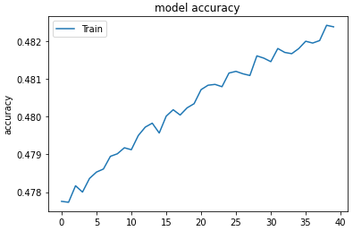

Figure 48 Plot Training Accuracy for Proposed Model

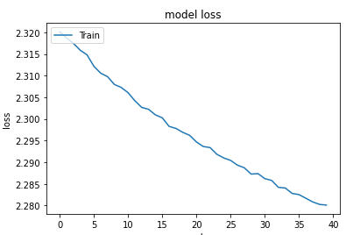

Figure 49 Plot Training Loss for Proposed Model

we used Resnet50 in this project as it scores the best accuracy and loss in 40 epochs.

Here we experiment ResNet50 model which is a type of CNN that is trained on COCO dataset to extract features from images with 2500 Epochs, 60.95% accuracy, 1.4873 loss, and the results as shown in figures 36,37,38,39,40,41 and 42:

Table 6 ResNet50 Results 2500 Epoch

|  |  |  |
| --- | --- | --- |
| Epoch 2482/2500  924/924 | loss: 1.4877 | accuracy: 0.6091 |
| Epoch 2483/2500  924/924 | loss: 1.4869 | accuracy: 0.6092 |
| Epoch 2484/2500  924/924 | loss: 1.4870 | accuracy: 0.6091 |
| Epoch 2485/2500  924/924 | loss: 1.4871 | accuracy: 0.6090 |
| Epoch 2486/2500  924/924 | loss: 1.4871 | accuracy: 0.6094 |
| Epoch 2487/2500  924/924 | loss: 1.4877 | accuracy: 0.6091 |
| Epoch 2488/2500  924/924 | loss: 1.4875 | accuracy: 0.6088 |
| Epoch 2489/2500  924/924 | loss: 1.4875 | accuracy: 0.6090 |
| Epoch 2490/2500  924/924 | loss: 1.4877 | accuracy: 0.6090 |
| Epoch 2491/2500  924/924 | loss: 1.4870 | accuracy: 0.6090 |
| Epoch 2492/2500  924/924 | loss: 1.4873 | accuracy: 0.6089 |
| Epoch 2493/2500  924/924 | loss: 1.4871 | accuracy: 0.6092 |
| Epoch 2494/2500  924/924 | loss: 1.4869 | accuracy: 0.6089 |
| Epoch 2495/2500  924/924 | loss: 1.4871 | accuracy: 0.6095 |
| Epoch 2496/2500  924/924 | loss: 1.4870 | accuracy: 0.6095 |
| Epoch 2497/2500  924/924 | loss: 1.4872 | accuracy: 0.6088 |
| Epoch 2498/2500  924/924 | loss: 1.4870 | accuracy: 0.6094 |
| Epoch 2499/2500  924/924 | loss: 1.4876 | accuracy: 0.6094 |
| Epoch 2500/2500  924/924 | loss: 1.4873 | accuracy: 0.6095 |

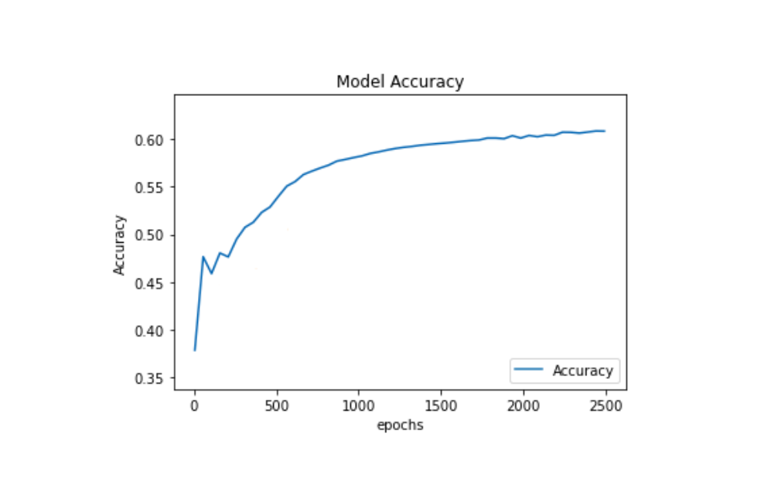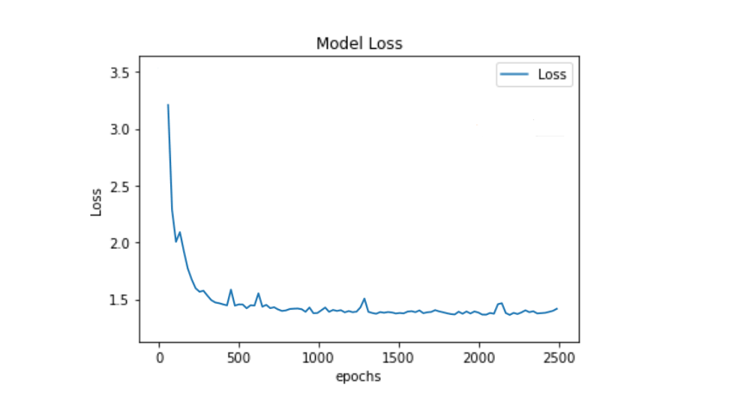

Figure 50 Plot Training Accuracy for Proposed Model

Figure 51 Plot Training Loss for Proposed Model

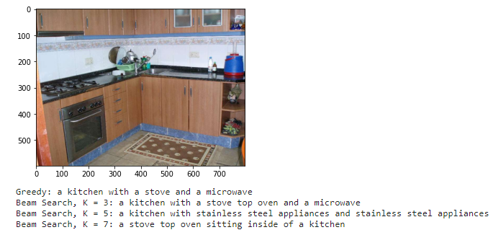

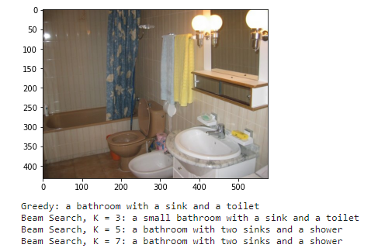

Figure 52 ResNet50 Prediction Example

|  |
| --- |
| Figure 53 ResNet50 Prediction Example |
|  |
|  |

|  |
| --- |
|  |
|  |

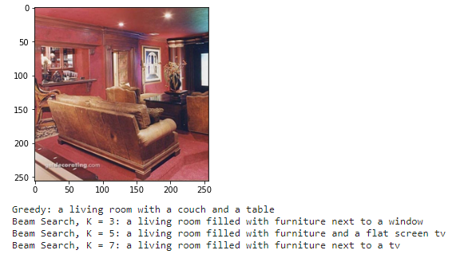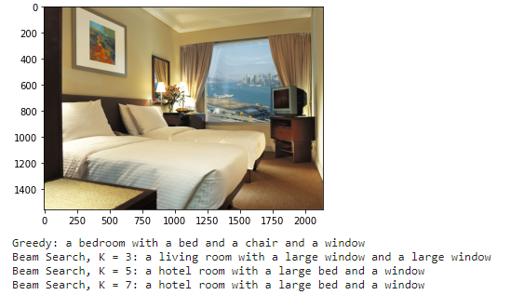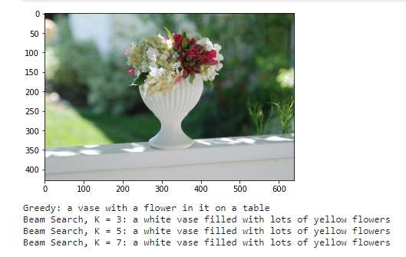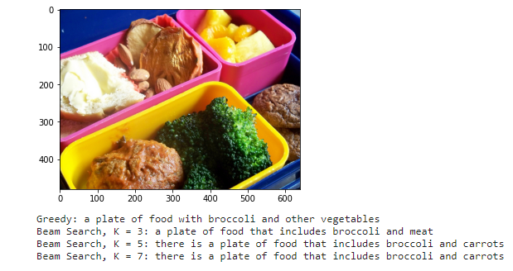

Figure 54 ResNet50 Prediction Example

Figure 55 ResNet50 Prediction Example

Figure 56 ResNet50 Prediction Example

Figure 57 ResNet50 Prediction Example

Chapter Seven

Conclusion & Future Work

# Future Work

* In the future, the model will be trained differently to be able to recognize assorted colours.
* Beam search will be better than greedy search as it returns a list of highest probability output sequences. only, if we could overcome the time problem of the response delay.
* The Mobile application will be able to calculate the distance between the user and the objects around him and warn him if he will hit something by using Proximity sensor.
* Reduce response time.
* It will also be able to detect the emotion of the person standing in front of the camera.
* In case we found a suitable camera that can be connected to the mobile and the application through a cable, we can add a navigation feature.

# Conclusion

According to a report by the World Health Organization, there are currently 284 million people in the world who are visually impaired, and 39 million people are blind. The society comes across millions of blind people in everyday life. The white cane is the most common used blind aid tool serving mobility purposes to the visually impaired people. These people with vision impairments lead difficult lives that cannot be managed without smart supportive techniques. They face many obstacles while performing their daily activities. It is very difficult for them to adapt to their lives with this disability.

We developed an application to try and make their life easier. We used many images with their captions along with a pre-trained model to recognize and describe the environment around them.

The learning method used is a Convolution Neural Network (CNN) and Long Short-Term Memory (LSTM), a proposed CNN-LSTM architecture is implemented, results are analysed and compared to other pre-defined method presented.

The application is developed using JAVA native language. It is installed on the user’s android mobile phone. When it is opened, it captures images automatically. Then, the captured image is transferred to the ResNet50 model using the API. The model detects and recognizes all the objects/places in the image and generates a description of it. The description then is converted to speech. Finally, the user receives the output as a voice message.

Chapter Eight

Glossary

**Use Case Diagram:** A use case is a methodology used in system analysis to identify, clarify, and organize system requirements.

**Accuracy:** Accuracy is one metric for evaluating classification models. Informally, accuracy is the fraction of predictions our model got right. Formally, accuracy has the following definition: Accuracy = Number of correct predictions Total number of predictions.

**Loss:** In mathematical optimization and decision theory, a loss function or cost function (sometimes also called an error function).

**Deep Learning:** a type of machine learning based on artificial neural networks in which multiple layers of processing are used to extract progressively higher-level features from data.

**Hardware:** the machines, wiring, and other physical components of a computer or other electronic system.

**System Architecture:** System Architecture defines a structure of a software system.

**User Interface:** how the user and a computer system interact.

**System Architecture Pattern:** Architectural patterns are a method of arranging blocks of functionality to address a need.

**VGG-16** is a convolutional neural network that is 16 layers deep. You can load a pretrained version of the network trained on more than a million images from the ImageNet database. The pretrained network can classify images into 1000 object categories, such as keyboard, mouse, pencil, and many animals.

**VGG-19** is a convolutional neural network that is 19 layers deep. You can load a pretrained version of the network trained on more than a million images from the ImageNet database. The pretrained network can classify images into 1000 object categories, such as keyboard, mouse, pencil, and many animals.

**Inception v3:** is an image recognition model that has been shown to attain greater than 78.1% accuracy on the ImageNet dataset.

**ResNet-50** is a convolutional neural network that is 50 layers deep. You can load a pretrained version of the network trained on more than a million images from the ImageNet database. The pretrained network can classify images into 1000 object categories, such as keyboard, mouse, pencil, and many animals.

**Long short-term memory (LSTM):** units or blocks are part of a. Recurrent neural networks (RNN) are made to utilize certain types of artificial memory processes that can help these artificial intelligence programs to imitate human thought more effectively.

**Epoch:** An epoch means training the neural network with all the training data for one cycle. In an epoch, we use all the data exactly once.

**Dataset:** a collection of data pieces that can be treated by a computer as a single unit for analytic and prediction purposes.

**Deep Learning Training:** Deep learning training is when a deep neural network (DNN) “learns” how to analyze a predetermined set of data and make predictions about what it means.

**Deep Learning Testing:** testing is referred to as the process where the performance of a fully trained model is evaluated on a testing set

**Application Lifecycle:** Application Lifecycle Management (ALM) is the specification, design, development, and testing of a software application.

# References

1. Sukrut Akolkar, Kedar Potdar and Chinmay D. Pai A Convolutional Neural Network based Live Object Recognition System as Blind Aid (November 27, 2018)
2. [Sai Nikhil Alisetti](https://www.researchgate.net/profile/Sai-Nikhil-Alisetti), [P. Swarnalatha](https://www.researchgate.net/scientific-contributions/P-Swarnalatha-2038593187), [Lav Mahtani](https://www.researchgate.net/profile/Lav-Mahtani) (December 2019) Guiding and Navigation for the Blind using Deep Convolutional Neural Network Based Predictive Object Tracking published in International Journal of Engineering and Advanced Technology(IJEAT).
3. Haikel Alhichri, Yakoub Bazi & Naif Alajlan (2020) Assisting all the Visually Impaired in Multi-object Scene Description Using OWA-Based Fusion of CNN Models published in Arabian Journal for Science and Engineering.
4. Jagadish K. Mahendran and his team (March 24, 2021) Intel AI-Powered Backpack Helps Visually Impaired Navigate World published in Intel Newsroom.
5. Sunit Ashish, Niti Bhavesh, Radha shankarmani(2020)  
   Real-Time_Object_Detection_for_Visually_Challenged_People.
6. [Kaushal Kumar](https://www.researchgate.net/profile/Kaushal-Kumar) (2020) An intelligent Assistant for the Visually Impaired & blind people using machine learning.
7. Pruthvi S, Pushyap Suraj Nihal, Ravin R Menon, S Samith Kumar, Shalini Tiwari (2019) Smart Blind Stick using Artificial Intelligence published in International Journal of Engineering and Advanced Technology (IJEAT).
8. Sreenu Ponnada, Srinivas Yarramalle(2019) Object Identification to Assist Visually Challenged published in International Journal of Engineering and Advanced Technology (IJEAT).
9. Kyungjun Lee (2020) Teachable object recognizers for the blind: using first-person vision.
10. Haikel Salem Alhichri, Yakoub Bazi, Bilel Bin Jdira, Naif Alajlan(2016) Multiple Object Scene Description for the Visually Impaired Using Pre-trained Convolutional Neural Networks.
11. Alice Lo Valvo, Daniele Croce, Domenico Garlisi, Fabrizio Giuliano and Laura Giarré, and Ilenia Tinnirello A Navigation and Augmented Reality System for Visually Impaired People.
12. E. Kodhai, A. Pooveswari, P. Sharmila, N. Ramiya(2020) Emotion Recognition System for VisuallyImpaired.
13. Pooja Bhagat (2022) Blind Person Assistant: Object Detection.
14. Yimin Lin, Kai Wang, Wanxin Yi, Shiguo Lian (2019) Deep Learning based Wearable Assistive System for Visually Impaired People.
15. Kalam Swathi, Bandi Vamsi & Nakka Thirupathi Rao (2021) A Deep Learning-Based Object Detection System for Blind People.
16. Sahar Busaeed, Rashid Mehmood, Iyad Katib and Juan M. Corchado LidSonic for Visually Impaired: Green Machine Learning-Based Assistive Smart Glasses with Smart App and Arduino.
17. Hassan Salam, Hassan Jaleel , Salma Hameedi(2021) You Only Look Once (YOLOv3): Object Detection and Recognition for Indoor Environment.
18. Bineeth Kuriakose , Raju Shrestha, Frode Eika Sandnes(2021) Towards Independent Navigation with Visual Impairment:A Prototype of a Deep Learning and Smartphone-based Assistant.
19. Samkit Shah, Jayraj Bandariya, Garima Jain, Mayur Ghevariya, Sarosh Dastoor CNN based Auto-Assistance System as a Boon for Directing Visually Impaired Person.
20. Abdul Muhsin M, Farah F. Alkhalid, Bashra Kadhim Oleiwi(2019) Online Blind Assistive System using Object Recognition.
21. M. Mukhiddinov, Jinsoo Cho (2021) Smart Glass System Using Deep Learning for the Blind and Visually Impaired.
22. Rakesh Chandra Joshi,Saumya Yadav ,Malay Kishore Dutta , andCarlos M. Travieso-Gonzalez (2020) Efficient Multi-Object Detection and Smart Navigation Using Artificial Intelligence for Visually Impaired People.
23. Daniel Pintado, Vanessa Sanchez, Erin Adarve, Mark Mata, Zekeriya Gogebakan, Bunyamin Cabuk, Carter Chiu, Justin Zhan, Laxmi Gewali, Paul Oh (2020) Deep Learning Based Shopping Assistant For The Visually Impaired.
24. C. Aggarwal Charu Neural Networks and Deep Learning Book (2022)
25. Friesen Jeff Learn Java for Android Development Book (2022)

COCO Dataset, <https://cocodataset.org/#home> [last accessed, Jun, 2022]

1. Inception V3 Model, <https://cloud.google.com/tpu/docs/inception-v3-advanced> [last accessed, June, 2022]
2. VGG19 Model, <https://iq.opengenus.org/vgg19-architecture/#:~:text=VGG19%20is%20a%20variant%20of,VGG19%20has%2019.6%20billion%20FLOPs> [last accessed, June, 2022]
3. LSTM, <https://intellipaat.com/blog/what-is-lstm/> [last accessed, June, 2022]
4. LSTM, <https://machinelearningmastery.com/gentle-introduction-long-short-term-memory-networks-experts/> [last accessed, June, 2022]
5. CNN-LSTM Architecture, <https://medium.com/analytics-vidhya/cnn-lstm-architecture-and-image-captioning-2351fc18e8d7> [last accessed, June, 2022]
6. VGG19 Model, <https://www.mathworks.com/help/deeplearning/ref/vgg19.html;jsessionid=4f6cfa5e5c44e8ed09b458abb907#:~:text=VGG%2D19%20is%20a%20convolutional,%2C%20pencil%2C%20and%20many%20animals> [last accessed, July, 2022]
7. VGG19 Architecture, <https://iq.opengenus.org/vgg19-architecture/#:~:text=VGG19%20is%20a%20variant%20of,VGG19%20has%2019.6%20billion%20FLOPs> [last accessed, July, 2022]
8. Challenges, <https://wecapable.com/problems-faced-by-blind-people/> [last accessed, July, 2022]
9. Beam Search, <https://machinelearningmastery.com/beam-search-decoder-natural-language-processing/> [last accessed, July, 2022]
10. Beam Search, <https://www.width.ai/post/what-is-beam-search> [last accessed, July, 2022]
11. Beam Search, [https://towardsdatascience.com/foundations-of-nlp- explained-visually-beam-search-how-it-works- 1586b9849a24#:~:text=Beam%20Search%20makes%20two%20improvements,considered%20each%20position%20in%20isolation](https://towardsdatascience.com/foundations-of-nlp-%20explained-visually-beam-search-how-it-works-%201586b9849a24#:~:text=Beam%20Search%20makes%20two%20improvements,considered%20each%20position%20in%20isolation). [last accessed, July, 2022]
12. ResNet50 Model, <https://iq.opengenus.org/resnet50-architecture/#:~:text=ResNet50%20is%20a%20variant%20of,explored%20ResNet50%20architecture%20in%20depth> [last accessed, July, 2022]
13. ResNet50 Model, <https://www.mathworks.com/help/deeplearning/ref/resnet50.html;jsessionid=51732ff784131582fd5ae90c6028> [last accessed, July, 2022]
14. ResNet50 Architecture, [https://cv-tricks.com/keras/understand-implement- resnets/#:~:text=Architecture%20of%20ResNet%2D50&text=The%20network%20can%20take%20the,224%20x%20224%20x%203](https://cv-tricks.com/keras/understand-implement-%20resnets/#:~:text=Architecture%20of%20ResNet%2D50&text=The%20network%20can%20take%20the,224%20x%20224%20x%203) [last accessed, July, 2022]
15. ResNet50 Model, <https://towardsdatascience.com/understanding-and-coding-a-resnet-in-keras-446d7ff84d33#:~:text=The%20ResNet%2D50%20model%20consists,over%2023%20million%20trainable%20parameters> [last accessed, July, 2022]
16. Transfer Learning, <https://machinelearningmastery.com/transfer-learning-for-deep-learning/> [last accessed, July, 2022]
17. Population of blind people, <https://www.blindlook.com/blog/detail/the-population-of-blind-people-in-the-world> [last accessed, July, 2022]